
ALGERIAN PEOPLE'S DEMOCRATIC REPUBLIC
MINISTRY OF HIGHER EDUCATION AND SCIENTIFIC RESEARCH
University of Mohamed El-Bachir El-Ibrahimi - Bordj Bou Arreridj
Faculty of Science and Technology
Department of Electronics
Master’s thesis
Presented to obtain
MASTER'S DEGREE
FIELD: Telecommunications
Specialization: Telecommunications Systems
By
- Boukedjar Yasmine
- Benkechida Wardia
Title
Study of an Intelligent Agriculture System based on IoT.

Defended on: …………………………

Before the Jury composed of:
Name & Surname | Position | Quality | Institution
Mr. ASBAI Nassim | MCB | Président | Univ-BBA
Mr. AIDEL Salih | Professor | Supervisor | Univ-BBA
Mr. ATTIA Salim | MCA | Examiner | Univ-BBA

Academic Year 2023/2024
Thankfulness
We are grateful to Almighty Allah for enabling us to complete this modest project. We would like to express our sincerest thanks to our master’s thesis supervisor, Mr. Salih Aidel, for accepting to supervise this work and for keeping us up to date throughout the process. We would also like to thank all the teaching staff especially Miss. Rania Djahaiche in the specialty (Telecommunication system) at the University of Bordj Bou Arreridj.
We would also like to thank the cleaning staff of the ST department for their hard work in maintaining the cleanliness of our college.
we are immensely thankful to my father for his crucial role in shaping the mechanical aspects of our master's thesis
His dedication, guidance, and technical expertise have been pivotal in realizing this project· His unwavering encouragement and belief in me have been invaluable,
Dad, your support and love mean everything to me Thank you for always being my rock and lending a helping hand
Finally, we would like to thank all those who have contributed to the success of this project, whether they were involved directly or indirectly (Mr. DJEDOUI)
Finally, we would like to thank ourselves for our belief in ourselves and our willingness to work hard.
Dedication
I would like to express my gratitude to ALLAH for His guidance throughout this journey.
The path was not always easy, but with His guidance, I was able to persevere and achieve my goal.
With heartfelt gratitude, I dedicate my graduation research to: myself, the strong-willed individual who overcame all obstacles and persisted despite the difficulties; to those whose prayers for my success were a source of strength; and to the light that illuminated my darkest moments,
my beloved mother. This accomplishment would not have been possible without your unwavering sacrifices.
I would also like to dedicate this achievement to those who supported me without limits and gave selflessly, my dear father, and to those who showered me with love, provided me with unwavering strength, and were the source of my reliance in all my struggles. I am truly grateful to have had such cherished friends, for through them, I have been able to experience the sweetness of life.
Boukedjar Yasmine
Dedication
First and foremost, I would like to express my highest gratitude to ALLAH S.W.T for the courage that he gave me in finishing this final year.
To my dear mother, the light of my life and the reason for my being.
To my father the flame of my heart who has always encouraged me to go so far, I hope you are proud of me.
To My Cherished Brothers and sisters.
To my dear friends, whose friendship is a treasure beyond measure.
To My Entire Family, young and old.
And to You, Dear Reader.
To All Who Love Me and Whom I Love.
Table des matières

Dédicace
Table des matières

Dedicate
I dedicate this modest work to you.

Benkechida.wardia

Abstract:
This master’s thesis discusses how the IOT can be used toward the development of an intelligent agriculture system, with a special focus on the design and implementation of our smart lawn mower project. The smart lawn mower includes advanced features, such as obstacle detection and independent working, offered by IoT technologies. By intelligently embedding sensors, actuators, and connectivity, the project develops the autonomy and efficiency of lawn care, achieving sustainable and productive outdoor care. Conclusions derived from this research indicate the applicability of IoT in increasing productivity and minimizing the impact on the environment in agricultural settings, and they provide insight into further projects seeking to use the power of IoT for smart farming solutions.
Key words:
IOT, Intelligent Agriculture System, Smart Lawn Mower, Obstacle Detection, Sensors, Actuators, Connectivity, Autonomy, Smart Farming.
Résumé :
Ce mémoire examine comment l’Internet des objets peut être utilisé pour le développement d’un système agricole intelligent, avec un accent particulier sur la conception et la mise en œuvre de notre projet de tondeuse à gazon intelligente. La tondeuse à gazon intelligente comprend des fonctionnalités avancées, telles que la détection d’obstacles et le travail indépendant, offertes par les technologies IoT. En intégrant intelligemment les capteurs, les actionneurs et la connectivité, le projet développe l’autonomie et l’efficacité de l’entretien des pelouses, en réalisant des soins extérieurs durables et productifs. Les conclusions tirées de cette recherche indiquent l’applicabilité de l’Ido à l’augmentation de la productivité et à la minimisation de l’impact sur l’environnement dans les milieux agricoles, et elles donnent un aperçu des autres projets visant à utiliser la puissance de l’Ido pour des solutions agricoles intelligente.
Mots clés :
Internet des objets, système agricole intelligent, tondeuse à gazon intelligente, détection d’obstacles, capteurs, actionneurs, connectivité, autonomie, agriculture intelligente.
ملخص:
تناقش هذه المذكرة كيف يمكن استخدام إنترنت الأشياء في تطوير نظام زراعي ذكي، مع التركيز بشكل خاص على تصميم وتنفيذ مشروع جزازة العشب الذكية. تتضمن جزازة العشب الذكية ميزات متقدمة، مثل اكتشاف العوائق والعمل المستقل، التي توفرها تقنيات إنترنت الأشياء. من خلال تضمين أجهزة الاستشعار والمشغلات والاتصال بذكاء، يطور المشروع استقلالية وكفاءة رعاية العشب، وتحقيق رعاية خارجية مستدامة ومنتجة. تشير الاستنتاجات المستخلصة من هذا البحث إلى قابلية تطبيق إنترنت الأشياء في زيادة الإنتاجية وتقليل التأثير على البيئة في البيئات الزراعية، وهي توفر نظرة ثاقبة على المزيد من المشاريع التي تسعى إلى استخدام قوة إنترنت الأشياء لحلول الزراعة الذكية.
الكلمات المفتاحية:
إنترنت الأشياء، نظام الزراعة الذكي، جزازة العشب الذكية، اكتشاف العقبات، المستشعرات، المشغلات، الاتصال، الاستقلالية، الزراعة الذكية.
Table of Contents

Chapter Ⅰ: Introduction to IoT
1 Introduction 2
2 Definition of the IOT (IoT) 2
3 Features of IOT (IoT) 3
4 Architecture of the IOT... 4
4.1 Sensing Layer 4
4.2 Network Layer 4
4.3 Data processing Layer 4
4.4 Application Layer 5
5 The different processes of the IOT 5
5.1 Data processing 6
5.2 Data transmission 6
6 The elements involved in the IOT [3] 7
6.1 The sensors 7
6.2 Connectivity 7
6.3 Information processing tools 8
6.4 User interface 8
7 IoT Essentials 8
7.1 RFID (Radio Frequency Identification) 8
7.2 WSN (Wireless Sensor Network) 8
7.3 M2M (Machine-to-Machine) 9
8 Communication technologies of connected objects 9
8.1 Short-range technologies 9
8.1.1 The NFC Protocol 9
8.1.2 Bluetooth 9
8.1.3 Zigbee 10
8.2 Mid-range technologies 10
8.2.1 Z-Wave 10
8.2.2 Wifi 10
8.2.3 Bluetooth Low Energy 10
8.3 Long-range technologies 11
8.3.1 Mobile cellular networks 11
8.3.2 Low-speed radio networks 11
8.3.2.1 Sigfox 11
8.3.2.2 LoRa 11
8.3.2.3 Proprietary networks 11
9 Business Areas 12
10 Advantages and Disadvantages of IoT 14
10.1 Advantages of IoT 14
10.2 IoT Disadvantages 14
11 Conclusion 15
Chapter Ⅱ: smart agriculture based IOT
1 Introduction 17
2 Applications of IoT in Agriculture (Tomar et al., n.d.) 17
2.1 Precision Farming 17
2.2 Livestock Monitoring 17
2.3 Supply Chain Management 18
2.4 Environmental Monitoring 18
3 IoT Technologies in Agriculture 19
3.1 Sensors in smart farming (Kose et al., 2022) 19
3.2 Connectivity Solutions 22
3.2.1 Cellular Networks 22
3.2.2 LPWAN Technologies 22
3.2.3 Lora WAN (Long Range Wide Area Network) 22
3.2.4 Narrow-Band IoT (NB-IoT) 22
3.2.5 Sigfox 22
3.2.6 Extraterrestrial connectivity 23
3.2.7 Data analytics (Singh Patel, n.d.-a) 23
3.2.8 Decision Support System (Singh Patel, n.d.-a) 23
4 Case Studies and Examples [5] 24
4.1 Drones (Kose et al., n.d.) 24
4.2 The robots (Romeo et al., 2020) 24
4.3 Agribots 25
4.4 The hoeing robot 25
4.5 Vine weeding robot 25
4.6 Intelligent driverless tractors (Tomar et al., n.d). 26
4.7 Automated greenhouses 26
4.8 Lawnmowers 27
5 Challenges in Smart Agriculture (Singh Patel, n.d.-b) 27
6 Conclusion 29

Chapter Ⅲ: smart lawnmower
1 Introduction Error! Bookmark not defined.
2 Project Objective 31
3 Arduino and Proteus Integration 31
3.1 Simulating and Testing: 33
4 Proposed Design 35
5 Methodology 38
5.1 Project Materials 38
5.2 Making parts 40
5.2.1 Chassis 41
5.2.2 Body 42
5.2.3 Cutter 43
5.2.4 Front plate 43
6 Schematics 44
7 Source Code 45
8 Final Preliminary Study 49
8.1 Recommendations and Future Work 53
8.2 Issues and requirements 54
9 Conclusion 54
10 References 59

List of Figures
Figure 1. IOT 3
Figure 2 . Architecture of IoT 5
Figure 3. IOT elements 7
Figure 4. IOT Applications 12
Figure 5 . precision farming 17
Figure 6. livestock monitoring 18
Figure 7. Conceptual architecture of iot in intelligent farming 20
Figure 8. Conceptual farmwork of robotics in farming 25
Figure 9. Intelligent driverless tractors 26
Figure 10. Automated greenhouse 27
Figure 11.lawnmower simulation 33
Figure 12.primeter station simulation 33
Figure 13. Relay simulation 34
Figure 14.chassis design 35
Figure 15.cutter design 36
Figure 16. lawnmower design 36
Figure 17.body design 37
Figure 18. Front plate design 37
Figure 19. Ultrasonic sensor Holder 38
Figure 20.chassis 41
Figure 21.wheel with brake 41
Figure 22. steps body construction 42
Figure 23.cutter 43
Figure 24.motors schematic 44
Figure 25.ultrasonic sensors schematic 44
Figure 26. fence sensor schematic 45
Figure 27. primeter station schematic 45
Figure 28.final thessis 50
Figure 29. Final perimeter station 51
Figure 30.fence sensor 51
Figure 31.lawnmower 52
Figure 32.Solar panel 53

List of Tables
Table 2. A comprehensive table with problem overviews and related IOT devices for plausible solution approaches intell intelligent Farming 19
Table 3. Common Mobile Apps and their Diverse Applications in Farming 21
Table 1.Diffrences between traditional and smart farming 24
Table 4.Part list 40

GENERAL INTRODUCTION
In the modern world, where technology is advancing rapidly, the application of the Internet of Things (IoT) in various industries has significantly transformed the interaction between humans and their environment. Agriculture, in particular, is experiencing a profound transformation. By leveraging IoT, farmers can monitor and manage their crops and livestock with unprecedented precision and efficiency. However, this technological revolution also brings new challenges, such as ensuring accessibility, cost-effectiveness, and user-friendliness of IoT solutions for all types of farmers. This master’s thesis addresses these challenges by exploring how IoT can be effectively integrated into agricultural practices to optimize efficiency and functionality. Specifically, it focuses on the design and implementation of an Arduino-based smart lawn mower, a project that exemplifies the potential of IoT to solve real-world problems in agriculture.
The thesis consists of three chapters. Chapter one introduces the basic concepts of IoT, describing how interconnected devices communicate and share data to optimize various processes. This chapter sets the foundation for understanding the application of IoT in different fields, including agriculture.
Chapter two delves into the application of IoT in agriculture, illustrating how smart farming techniques can help farmers make informed decisions. It examines the benefits and challenges of integrating IoT into agricultural practices, emphasizing the need for solutions that are accessible, affordable, and easy to use.
Chapter three brings theory to practice with our smart lawn mower project. This chapter details the development process, the challenges encountered, and the solutions implemented. The problematic addressed here is the significant effort required for lawn maintenance and how IoT can alleviate this burden. By connecting available devices and machines, we aimed to change the way these activities are managed. Our smart lawn mower project, driven by the concept of IoT, seeks to improve user management and demonstrate the transformative potential of IoT in making everyday tasks easier and more efficient. This chapter underscores our commitment to creating technology-driven solutions for a more accessible and efficient future.

Chapter Ⅰ

- Introduction
Thanks to fierce competition among producers, technical progress, and lower costs for sensors and network devices, there has been an increase in the number of objects connecting to the internet daily.
The general idea revolves around the ability of network devices to identify and gather information from our surroundings, which is then shared on the internet for processing and utilization. Some individuals also refer to this as the Industrial Internet.
Applications are primarily what is being referred to when we talk about the IOT.
This chapter will provide a comprehensive overview of the IOT, starting with general information. We will delve into its diverse application areas, including cities, energy, transportation, health, industry, and agriculture. Additionally, we will explore essential components like sensors and actuators, detailing their unique characteristics.
- Definition of the internet of things (IoT)
The CERP-IoT, known as the “Cluster of European Research Projects on the IOT,” defines the IoT as a dynamic infrastructure that links a global network.
This network possesses self-configuring abilities based on interoperable communication standards and protocols. Within this interconnected system, both physical and virtual objects have distinct identities, physical attributes, virtual personalities, and intelligent interfaces seamlessly integrated into the network. This IoT concept introduces a novel dimension to information and communication technologies by adding an “object” dimension alongside the existing temporal and spatial dimensions, enabling connectivity not only between people but also with any object.

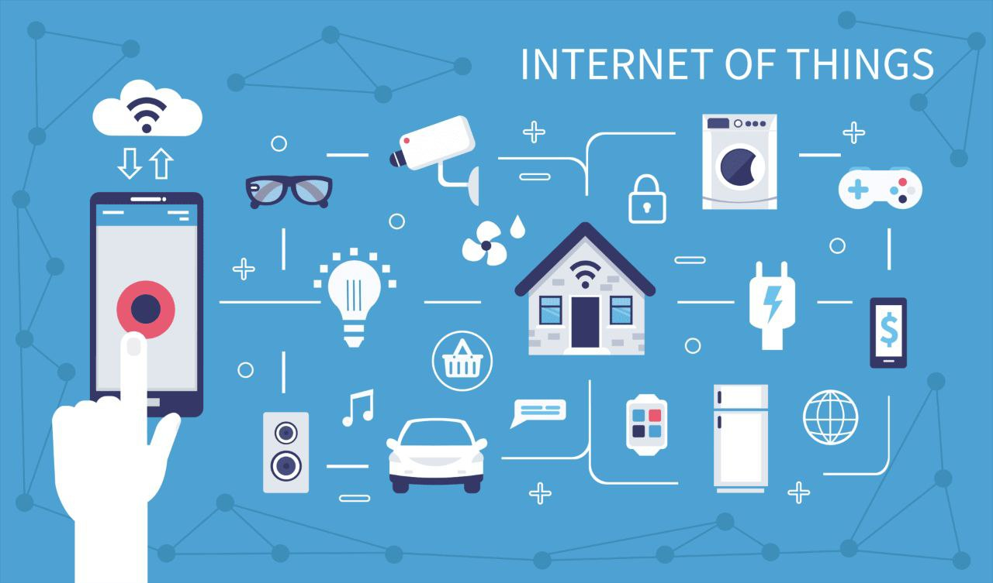
Figure 1. IOT
- Features of IOT
Any IoT device comes up with the following features: [1]
- Connectivity The IOT (IoT) facilitates the interconnection of devices, enabling seamless data exchange and communication.
- Sensors and Data IoT devices are integrated with sensors that gather diverse data types such as temperature, location, and more.
- Automation IoT technology empowers automation and control of devices and processes, diminishing the necessity for human intervention.
- Remote Monitoring and Control Numerous IoT devices offer remote monitoring and control capabilities through mobile applications or web interfaces.
- Interoperability IoT devices and systems are required to function harmoniously, often across various manufacturers and protocols.
- Data Analytics IoT generates extensive data volumes that can be analyzed to extract insights and support informed decision-making.
- Real-Time Capabilities Certain IoT applications demand real-time data processing and immediate responses.
- Scalability IoT systems must be scalable to accommodate a growing number of devices and data sources effectively.
- Security and Privacy Ensuring robust IoT security is paramount to safeguard data and prevent unauthorized access to devices.
- Energy Efficiency Many IoT devices are engineered for optimal energy usage to promote efficiency and prolong device lifespans.
- Architecture of the IOT [2]
Technology has a wide variety of applications and the use of the IOT is growing fast. Depending upon different application areas of the IOT, it works accordingly as it has been designed/developed. It does not have a standard defined architecture of working which is strictly followed universally. The architecture of IoT depends upon its functionality and implementation in different sectors. Still, there is a basic process flow based on which IoT is built.
  - Sensing Layer
The first layer of the IoT architecture is the sensing layer which is the one responsible for collecting data from different sources including sensors and actuators that are placed in the environment to gather information about temperature, humidity, light, sound, and other physical parameters; these devices are connected to the network layer using either wired or wireless communication protocol.
  - Network Layer
Under an IoT framework, the network layer is charged with the duty of providing communication and connectivity amidst devices within the IoT system. It encompasses protocols and technologies that make it possible for devices to link and communicate with each other as well as the broader internet. Examples of network technologies which find applications in IoT include Wi-Fi, Bluetooth, Zigbee alongside cellular networks such as 4G & 5G. Moreover, gateways plus routers acting as intermediaries between these gadgets & wider internets may be included at this level; also, security measures like encryption for confidentiality or authentication procedures against unauthorized access could be implemented here too.
  - Data processing Layer
The data processing layer of IoT architecture means the software and hardware that gathers, analyzes, and interprets information from IoT tools. It processes raw information received from the devices and makes it available for further analysis or action. A variety of technologies and tools are involved in data processing layers such as data management systems, analytics platforms, and machine learning algorithms. These helps extract useful insights and decisions out of them. [3]
  - Application Layer
IoT architecture’s application layer is the highest level of the architecture where interaction with the user takes place directly. It is charged with the responsibility of creating friendly interfaces, which would enable users to access and manipulate IoT devices. This layer contains various kinds of software as well as applications like mobile apps, web portals among others being user interfaces meant to communicate with the underlying infrastructure of IoT. There are also middleware services in this layer allowing for seamless communication and sharing of data between different devices and systems within IoT. Analytics capabilities are included in addition to processing which enables analyzing information gathered transforming it into more valuable insights; this may involve machine learning algorithms, data visualization tools plus other advanced types of analytics.
Below is an illustration of some of the different layers in IoT architecture:
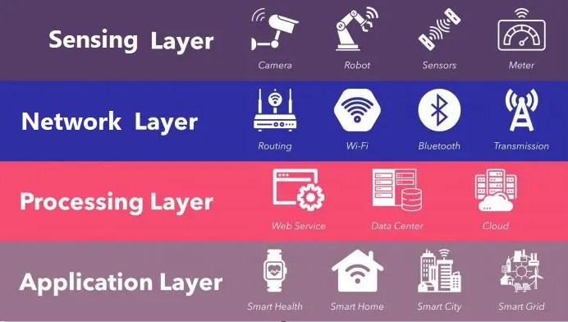
Figure 2 . Architecture of IoT
- The different processes of the IOT
- Capture
This process converts analog physical quantities into digital signals that can be used by electronic devices.
- Focus
This step allows interconnection between a specialized network of objects and a standard IP network such as Wi-Fi or other consumer devices.
- Store
The storage process involves aggregating and storing raw data from sensors. This data can be produced in real-time, with metadata added for better organization and identification.
- Present
Finally, this stage is about returning the information to the user in an understandable way. This can be done through a graphical user interface, dashboard, or mobile application, enabling users to view analyze, and interpret IoT data.
  - Data processing
Data processing is a critical process that can involve any stage of the chain from information capture to information presentation. A common and effective strategy in IoT is to store information in its complete form. This approach requires comprehensive data collection, often referred to as “big data,” without making assumptions about subsequent data processing. Today, this strategy is made possible by distributed architectures such as NoSQL, which are capable of storing large amounts of data while making it easier to perform complex data processing tasks.
  - Data transmission
The process occurs across all levels of the chain. Two networks that facilitate transmissions typically coexist:
- Local Area Network (LAN) Concentration: Technologies like ANT, ZigBee, Z-wave, NFC, or Bluetooth LE are employed.
- Wide Area Network (WAN) for linking specialized networks and interfacing with server farms. This involves the utilization of Wi-Fi, cellular networks (GSM, UMTS, LTE), or standard physical connections (Ethernet, optical fiber). These networks are commonly linked to the Internet.
The selection of transmission technologies primarily hinges on the application and context. Channels may support bidirectional communication if feedback is required. In certain scenarios, real-time data transmission is imperative, while in others, timing may not be a critical factor.
- The elements involved in the IOT [4]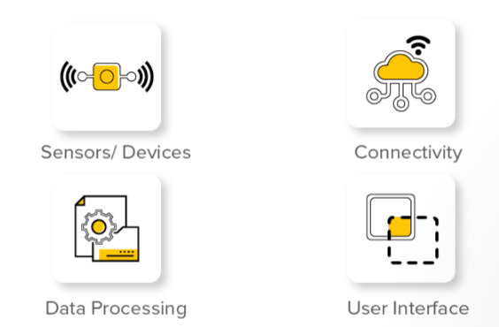
Figure 3. IOT elements
  - The sensors
Devices or sensors are used for data collection and implementation from gathered information. For instance, this is in tasks like temperature and humidity measurements. Sensors differ as there are those for temperature, humidity, proximity motion light intensity, pressure gas level detection, also GPS signal collection. [5]
  - Connectivity
IOT’s heart lies in connecting different gadgets together thus enabling them transfer data seamlessly. Wi-Fi modules among others which are involved in communication between devices include Bluetooth Low Energy (BLE), Zigbee etcetera so forth till cellular networks for mobile phones especially smartphones equally serve their purpose by making sure that the signal strength is high enough on both ends i.e., where it’s being transmitted from as well as where it’s supposed go to in order to avoid any loss of packets during these processes.
  - Information processing tools
Data collection, processing, and analysis are critical to gaining valuable insights. Computing devices, from edge computing devices to cloud servers, manage the computational work required to transform raw data into actionable information. Edge computing works close to the data source, minimizing latency, while cloud servers handle more demanding computing tasks.
  - User interface
user interfaces are commonly known as UI and act as a link between users and applications or systems. Some of the major features for IoT user interfaces are data visualization, easy-to-use design, customization, remote monitoring, integration, authentication, security etc...
- IoT Essentials
is a network of objects that are interconnected and can collect and exchange data over the Internet by making use of embedded sensors, software, and network connectivity. This allows for remote control and management of such devices. IoT hardware depends on various technologies like Wi-Fi, Bluetooth for connections with other gadgets, GSM, 4G LTE, 5G NR or NB-IoT networks which enable real-time tracking, performance monitoring as well as behavior manipulation among others. [6]
  - RFID (Radio Frequency Identification)
works by transferring data through radio-frequency electromagnetic fields between tags on objects and readers. They are made up of tags–these store information about what is being tracked or monitored; readers–these can be fixed in place or portable and communicate with the tags by sending an appropriate signal; antennas transmit energy that powers the tags response as well as allowing them to be read from a distance.
  - WSN (Wireless Sensor Network)
WSN has spatially distributed sensors and one or more receiver nodes. Sensors keep an eye on physical conditions and produce the sensing data that is accrued by the receiver. WSN could be used for different purposes which include IoT, surveillance, environment monitoring, and more. [7]
  - M2M (Machine-to-Machine)
M2M refers to the use of wired or wireless communication technology in order to enable exchange of data amid mechanical or electronic devices. It encompasses various transport methods such as serial ports, traditional PLCs, wireless connections like cellular, Bluetooth, Wi-Fi, RFID, and fiber optics.
- Communication technologies of connected objects
  - Short-range technologies
    - The NFC Protocol
The NFC Protocol, short for Near Field Communication, operates on radio frequency identification (RFID) technology. Objects embedded with an RFID electronic chip, known as a “tag,” are automatically recognized via radio frequency when in proximity to a device called an interrogator. NFC serves as a standard for radio frequency communication and has garnered attention from the European Commission for environmental protection directives. This technology finds widespread application in various industries, such as providing access badges for secure premises in corporate settings and facilitating subscriptions for public transportation networks.
    - Bluetooth
Bluetooth, is a standardized wireless data transfer protocol known for its low bandwidth capabilities, enabling efficient data transmission over short distances while maintaining high energy efficiency. Widely integrated into mobile phones, Bluetooth facilitates communication between devices such as phones and various connected objects like wireless headsets, smartwatches, heart rate monitors, portable speakers for music streaming, weather stations, thermostats, and more. Additionally, Bluetooth technology is utilized in stationary sensors known as beacons for applications such as flow measurement, including tracking customer traffic in retail environments. [8]
    - Zigbee
Zigbee is a radio communication protocol tailored for home automation purposes, characterized by an average range of 10 meters, low bandwidth utilization, and optimized for efficient low-volume data transmission. Noteworthy for its low energy consumption and tailored for applications requiring low data rate exchanges, Zigbee devices are well-suited for battery-powered devices, especially sensors. Operating within a mesh network architecture, each node within the network is capable of receiving, transmitting, and relaying data. This protocol finds application in various devices, including smoke detectors, where its mesh networking capabilities enhance reliability and coverage. [8]
  - Mid-range technologies
    - Z-Wave
Z-Wave is a wireless communication protocol primarily designed for home automation applications, offering data transmission capabilities spanning from 30 meters indoors to 100 meters outdoors. Operating within a mesh network architecture, each interconnected device can relay information from neighboring devices, effectively extending the network’s reach. Engineered for energy-efficient operations necessitating low data rates, the Z-Wave protocol, similar to Zigbee, boasts minimal power consumption requirements, enabling devices to communicate for extended periods using standard batteries. [9]
    - Wi-Fi
Wi-Fi encompasses a range of wireless communication protocols that facilitate broadband connectivity within distances of 20 to 100 meters. This technology establishes a local network known for its high energy consumption, making it most suitable for devices connected to a power source or those with convenient and reliable power access. Wi-Fi excels in rapid data transfer capabilities, enabling efficient transmission of large volumes of data. Diverse Wi-Fi standards exist to cater to specific requirements, offering varying ranges and speeds tailored to different connectivity needs. [9]
    - Bluetooth Low Energy
Bluetooth Low Energy (BLE), also recognized as Wire, is a highly efficient wireless personal network protocol characterized by its minimal power consumption. Operating similarly to traditional Bluetooth, BLE is capable of transferring a restricted volume of data over an average distance of 60 meters. The key distinction between Bluetooth and BLE lies in the energy efficiency of communication, with BLE consuming approximately ten times less power compared to standard Bluetooth technology. [8]
  - Long-range technologies
    - Mobile cellular networks
Delivered by telecommunications providers, mobile cellular networks, utilizing GSM technology, facilitate the efficient transfer of substantial data over extensive distances. These networks necessitate the insertion of a SIM card into the device for identification within the communication network. Evolving from earlier generations of mobile telephony standards that have progressively enhanced communication speeds, the fourth generation (4G) enables exceptionally high-speed mobile communication capabilities.
    - Low-speed radio networks:
      - Sigfox
is a low-frequency, low-speed wireless radio communication network known for its average range of 10 kilometers in urban regions and extending to 30 to 50 kilometers in rural areas. Developed by the eponymous company, Sigfox technology is tailored for low-power devices, offering extended operational autonomy and facilitating the efficient transmission of small data packets [9]
      - LoRa
is a radio communication protocol characterized by its minimal power consumption, enabling the transmission of small data payloads over distances ranging from 2 to 5 kilometers in urban settings and extending up to 45 kilometers in rural environments. Similar to Sigfox, LoRa is well-suited for energy-efficient devices that transmit intermittently, making it particularly suitable for applications involving sensors and other low-power equipment. [9]
      - Proprietary networks
Certain major industrial entities, equipped with significant financial capabilities, opt to establish their dedicated communication networks. The implementation of these private or proprietary networks proves particularly advantageous when deploying a large number of interconnected devices. For instance, m2ocity, a joint venture between Veolia Water and Orange, has chosen to deploy its exclusive communication network to interconnect smart water meters for remote meter reading operations, a strategy also adopted by Suez. Additionally, GRDF’s advanced metering system for residential natural gas consumers relies on a specific proprietary long-range radio protocol. This system utilizes a dedicated radio frequency band (169 MHz) to facilitate seamless data communication between the meters and data concentrators, which in turn relay the collected information to the central information system.
- Business Areas
The IOT (IoT) through data and technology intelligence is a game changer in many fields. [10]
- Smart Homes design functional IoT applications for energy efficiency, device reliability, and security or low cost. Automation is achieved through the installation of the environmental controls, lighting, access controls, plants watering, pets care, maintenance scheduling, safety and fitness including the door locks, sensors, cameras and alerts.
- Smart cities Similarly, to IOT services, the effective implementation of public resources production, services quality and operating costs optimization in smart cities is also crucial. Smart cities encompass smart buildings, energy management systems, transport enhancements, safety measures, environmental monitoring systems and infrastructure management for future urban planning of cities. Smarter city employs the transportation systems such as traffic monitoring, route planning, maintenance services and connected vehicles which is the main part of the smartness in the self-driving cars.
- Smart Grids receive data from smart meters and sensors to deliver environment-friendly as well as cost-effective but reliable power supply. IoT platforms in agriculture monitor soil humidity, the condition of the plants, the micro-climate, and the weather, resulting in a higher yield, cost-effectiveness and environmental friendliness. The Internet of Food is a platform that unites production, processing, transportation, storage, retailing and consumption with safety measures, efficiency, waste reduction and disclosure in food supply chain
- Industrial IoT and smart factories Industries 4. 0 revolution. The said model would be centered on factories that have the capability to automate difficult tasks such as Machine-Device Communication in assembling individualized and short volume products.
- Healthcare IoT in healthcare ensures remote diagnosis, supervision and management of resources, and eventually, patients will access better treatment. Smart watches are wearables that can measure vital signs, activity level and heart rate. They can do remote monitoring, patient care, self-monitoring, smart pills, medical robotics for accurate surgery, rehabilitation and hospital services. [11]
- Internet of Military Things (IoMT) by factor of precision targeting that the IOT gives; it is much more effective than fast war machines. An important strategic benefit among others gained by in integration is that the capability of the assets (ships, aircraft, tanks, and ground soldiers) to coordinating and share intelligence across different types and platforms is vital for the effective joint command and control and combat operations in a 360-degree situation awareness. Cybersecurity is another security problem encountered in IoT, Robotics, and AI military applications that are sometimes characterized by automation, high precision, and fewer casualties.

- Green and sustainable IoT through the application of IoT for pollution control, climate change and resource management. It is applied in many areas such as agriculture for increasing irrigation efficiency, energy consumption reduction, infrastructure development, environmental pollution prevention and hazard removal, resources conservation, and emission less as well as pollution-free supply chain.
Some of the applications of the IoT which have been stated are available in industries as well. These apps of the IoT are only a few from the applications of the IoT in general that will be discussed.
Below is an illustration of some of the IoT Application :
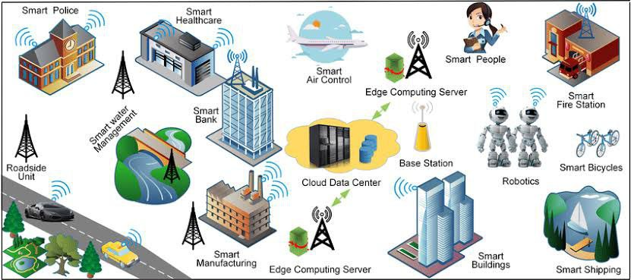
Figure 4. IOT Applications
- Advantages and Disadvantages of IoT
  - Advantages of IoT
Below are the key advantages of IoT technology [12]
- Technological Optimization: IoT technology leads greatly to the advancement and development of technologies. For example, a manufacturer may collect data from different car sensors using IoT. The manufacturer analyses them to enhance their design and make them more effective.
- Enhanced Data Collection: Conventional data collection has drawbacks and is structured for passive use. IoT allows for quick action on data.
- Less Waste: IoT provides real-time information, allowing for more efficient decision-making and resource management. For example, suppose a manufacturer discovers a problem in several car engines. In that case, he will monitor the production plan of such engines and resolve the problem using the manufacturing belt.
- Improved Customer Engagement: IoT helps you enhance customer service by identifying challenges and enhancing processes.
  - IoT Disadvantages
Now, in this IOT, let us look at some of the drawbacks of IoT:
- Security IoT technology produces a network of interconnected devices. However, the device can have little authentication control despite adequate security precautions during this phase.
- Privacy IoT reveals a large volume of sensitive data in extreme detail without the user’s direct consent. This raises a slew of privacy concerns.
- Flexibility The flexibility of an IoT system is a big problem. It is mostly concerned with integrating with another system since several systems are involved.
- Complexity The IoT system’s architecture is often very difficult. Furthermore, deployment and servicing are difficult.
- Compliance The IOT has its collection of rules and regulations. However, owing to its complexity, the task of compliance is very difficult.

- Conclusion
Within this chapter, we have introduced various communication technologies that are integral to the IOT. We have explored their operations, development, and overall architecture. Additionally, we have referenced a few examples.
The IOT has made a profound impact in various sectors. Furthermore, it has proven to be an effective tool in simplifying people’s lives. Developed countries, in particular, have embraced this technology as an essential resource. It is undeniable that everyday objects now possess remarkable intelligence, as highlighted in this chapter.

Chapter Ⅱ

- Introduction
The IOT (IoT) is revolutionizing agriculture by optimizing productivity and breaking down technological barriers· This digital technology empowers farmers to embrace innovation, overcome challenges, and gain insights crucial for success· By leveraging IoT, farmers can monitor soil acidity, temperature, and weather conditions continuously, enhancing productivity· IoT-based devices also facilitate livestock monitoring and provide essential data on rainfall, yields, pests, and soil nutrition in real-time· With precise data, farmers can refine techniques and boost productivity· Moreover, IoT streamlines agricultural logistics, ensuring a seamless and efficient supply chain
- Applications of IoT in Agriculture
  - Precision Farming:
Is a system of precision farming in which the variability within the field is controlled in a defined and procedural manner based on information technology. Precision farming is to be implemented by managing fields as a function of the spatial variability of the availability of nutrients and expected crop yield. Precise farming is a concept specifically for use in agriculture for economic and ecological purposes, primarily through less use of materials, machinery, and work hours, and the associated environmental degradation. The whole production process is documented.
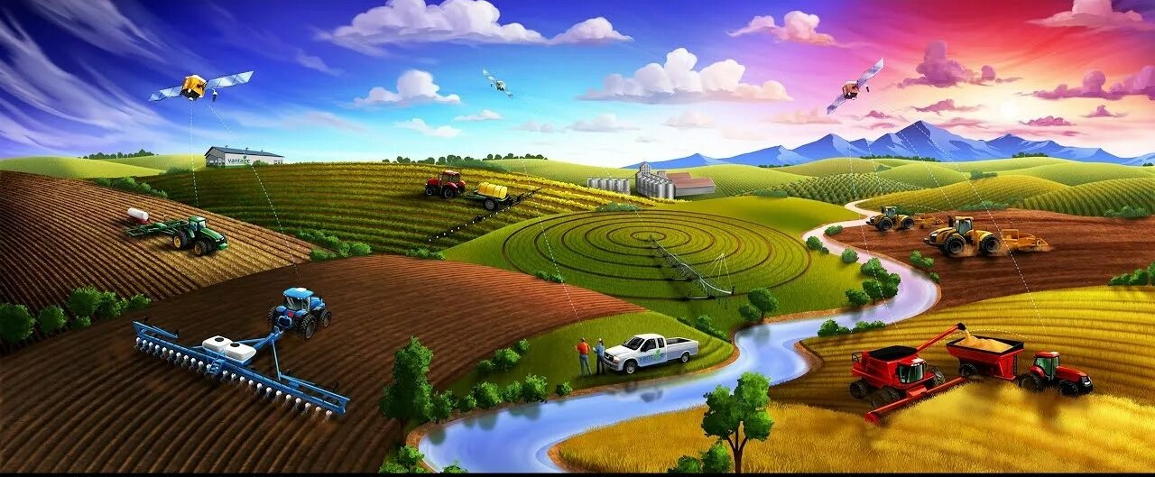
Figure 5 . precision farming
  - . Livestock Monitoring
According to the World Economic Forum, through sensors, with livestock management enabled by IoT, data on the health, environment and behavior of the livestock can be collected to: monitor digital vitals such as heart rate and temperature, containing diseases outbreaks, monitoring for behavioral abnormalities, and optimizing grazing patterns. It also tracks and manages reproductive cycles. Through IoT technology, farmers can track and manage reproductive cycles ensuring safe calving of healthy offspring. [13] 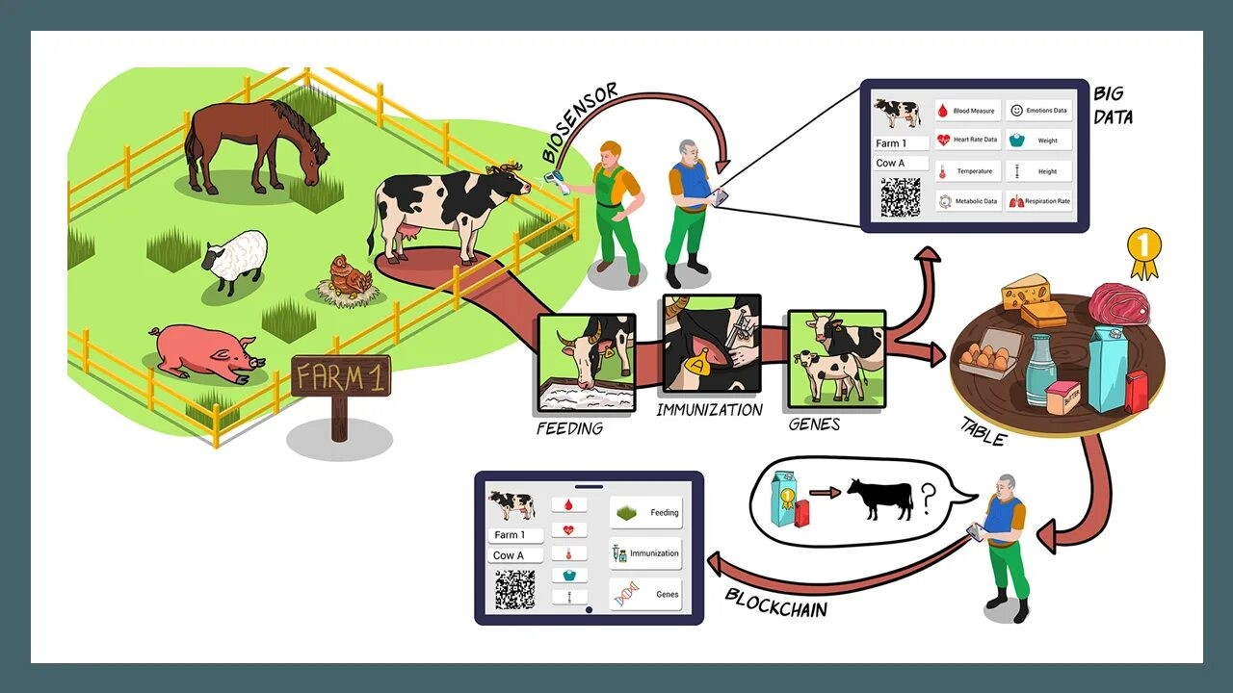
Figure 6. livestock monitoring
  - Supply Chain Management
In agriculture, IoT technology can help to promote improvements in supply chain management, while enhancing transparency between all relevant parties, including farmers, transporters, distributors, and ultimately consumers. This can be achieved through IoT sensors that monitor products during their journey from farm to table and provide real-time communication about their location and condition, thus empowering farmers and distributors to make informed decisions regarding inventory levels, the optimal use of storage spaces and the quality of the products. IoT also enables real-time tracking of inventory levels and is used to prevent machinery breakdowns and keep machines working seamlessly. [14]
  - Environmental Monitoring
For agriculture purposes, IoT gadgets can measure temperature, humidity, air quality and other environmental factors. This information can be employed to streamline crop growing besides reducing negative effects caused by bad weather or other harmful elements on industrial farming thereby making it sustainable and adaptable.
Below is a comprehensive table including problem overviews and related IoT devices for plausible solution approaches in intelligent farming
Table 1. A comprehensive table with problem overviews and related IOT devices for plausible solution approaches intell intelligent Farming
Addressed problem | Input parameter | Data Controller | Data transmission | Data display
Mushroom cultivation monitoring system | Humidity sensor, MQ-135 CO2 gas sensors | Arduino IDE | Wi-Fi | Thing Speak
Potato late blight  Prevention method | Temperature, humidity, freeze sensors | Cloud | Wi-Fi, Bluetooth, ZigBee, etc. | Smartphone, laptop, desktop
Agriculture monitoring system | Temperature, humidity sensors | Arduino Uno | Wi-Fi, Ethernet Shield | Smartphone, laptop, desktop
Agriculture monitoring system in rural areas | Temperature, humidity, pressure, luminosity, soil moisture, etc., sensors | Raspberry Pi | Wi-Fi | Web-based interface
Watering management system | Water level, soil moisture, temperature, humidity, rain intensity sensors | Arduino | Wi-Fi | LCD screen
Simulated water management | Various simulated sensors | Various simulated engine | Wi-Fi | Application services
Strawberry disease prediction system | EC1, pH, temperature, humidity,  CO2 sensors | Cloud | Long-range wide area network | Smartphone

- IoT Technologies in Agriculture
  - Sensors in smart farming
Smart farming incorporates various types of sensors to enhance agricultural practices by adapting to environmental changes and improving crop management.
The following sensors are commonly used in drones, robotics, and weather stations to optimize agricultural processes: [8]
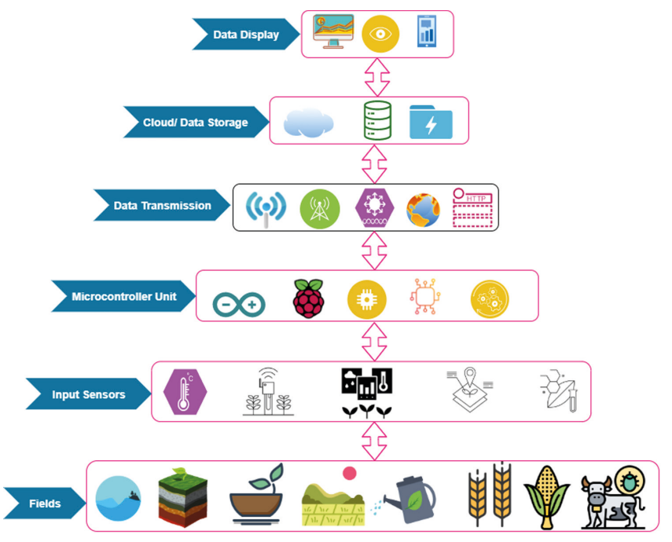
Figure 7. Conceptual architecture of iot in intelligent farming
- Acoustic sensors These sensors monitor and analyze noise levels for applications such as soil management, fruit harvesting, weeding, pest detection and classification, seed variety identification, and pest monitoring.
- Optical sensors Based on light analysis, these sensors determine organic matter and mineral content in soil by analyzing soil density and characteristics. Optical sensors using fluorescence identify mature fruits and classify crops. They also characterize grove canopies when combined with microwave scattering.
- Ultrasonic ranging sensors Cost-effective and versatile, these sensors are suitable for various applications, including tank monitoring, spray distance measurement, crop canopy monitoring, and weed detection.
- Telematics sensors These sensors interlink agricultural devices for data collection, remote machinery operation, and data recording for automatic operations.
- Argos sensors Used for remote sensing, these sensors collect geographic data for crop analysis, yield forecasting, and pest identification.
- Soft water level-based (SWLB) sensors: SWLB sensors assess the hydrological behavior of farms, measuring water flow and level, stream prediction, and water presence.
- Field-programmable gate array (FPGA)-based sensors: FPGA-based sensors provide real-time plant transpiration, irrigation, and humidity monitoring, addressing power consumption and cost challenges.
- Temperature sensors Used to measure environmental temperature in analog or digital mode, these sensors are not limited to agriculture and are also used in automobiles and air-conditioning systems.
- Soil-moisture sensors These sensors determine soil moisture content, assisting farmers in achieving optimal moisture levels for precision farming.
- Airflow sensors These sensors assess soil air permeability and moisture content, identifying soil structure to differentiate between various soil types.
- Electrochemical sensors Primarily used to determine soil nutrient quantities, electrochemical sensors offer a cost-effective alternative to traditional soil analysis methods, detecting macro and micronutrients, as well as salt and pH levels in the soil.
These sensors contribute to the advancement of smart farming, enabling farmers to make informed decisions and optimize crop management
Table 2. Common Mobile Apps and their Diverse Applications in Farming
Mobile apps | Applications
Pocket LAI | Irrigation
LandPKS | Soil assessment
AMACA | Machinery/tools
Ecofert | Fertilizer management
AgriMaps | Land management
Snap Card | Spraying applications
SWApp | Irrigation
Weed Smart | Weed management
Village Tree | Pest management
WISE | irrigation
EVAPO | Irrigation
Bio Leaf | Health monitoring
cFertigUAL | Fertigation
  - Connectivity Solutions
    - Cellular Networks
Cellular technologies like 2G, 3G, 4G, and 5G offer long-range wireless connectivity, but they have limitations like high power consumption and monthly subscription fees. 5G offers high-speed communication but lacks information on combining it with low power consumption, making it unsuitable for energy-constrained IoT devices.

    - LPWAN Technologies
LPWAN technologies offer lower power consumption and data rates, wider coverage, and more massive connections compared to traditional cellular systems. These technologies are ideal for devices that only transfer small amounts of data but are not recommended for audio or video data streaming.
    - Lora WAN (Long Range Wide Area Network)
Lora WAN connects LoRa gateways to sensors, providing larger coverage using a single gateway. However, it has limitations like transmitting more than 36 seconds per hour and supporting half-duplex communication, affecting message and payload time. The latest modules also limit data transmission.
    - Narrow-Band IoT (NB-IoT)
NB-IoT is a mobile communications protocol with a 180 kHz bandwidth, but its reduced data rates and lack of handover make it challenging to update firmware over the Air and deploy.

    - Sigfox
Sigfox is a LPWAN technology that uses Ultra-Narrow-Band modulation to reduce noise and improve communication rates, suitable for lightweight IoT devices, and offers limited down-link and up-link communications.

    - Extraterrestrial connectivity
Satellite and microwave technologies are used for IoT connectivity when cellular and fiber options are not feasible, such as in national defense for unmanned drones. These options offer low-to-medium bandwidth, high range, and medium reliability, but are primarily used in a few industries.
    - Data analytics
Data analytics is crucial in today’s world, as it generates large amounts of real-time data, images, videos, and social media data, enabling the processing of decisions. Big data analytics extends beyond farming to address sustainability, climate change, and predictive insights in farming operations. It helps farmers make real-time decisions, manage risks, improve efficiency, and secure food. By providing farmers with data like water cycles, fertilizer requirements, and rainfall patterns, they can make informed decisions about crop planting and harvesting, leading to improved farm yields. Distributors can also identify inefficiencies in their supply chains, ensuring faster and more cost-effective delivery of agricultural products. This allows farmers to apply the right products at the right rates, manufacturers to improve production, and distributors to maximize market advantage. Without analytics, no accurate decision can be made.
    - Decision Support System
A Decision Support System (DSS) is a tool that aids in making efficient decisions from large datasets in agricultural processes. It provides an interpretable user interface, enabling users to make informed decisions. The IoT facilitates data collection and transmission, sensor data is used for monitoring and control, robotics provides automation, cloud environments offer computational capacity, AI-based data analytics utilizes statistical methods, and DSS tools support agricultural management. This creates an ecosystem for sustainable agriculture, enabling farmers to achieve better price control and yield production by combining disruptive technologies. DSS aids in making complex decisions from large datasets.
Here is a concise table comparing the key differences between traditional farming and smart farming
Table 3.Diffrences between traditional and smart farming
Traditional Farming | Smart Farming
Application of fertilizers and pesticides throughout the field | Field and finance data available in the same place.
Geo-tagging and zone detection not possible | It can detect the zones in farms with the help of satellites
Manual maintenance, separate finance data, and leading to errors | Early detection and application in the affected region
Weather prediction not possible | Weather analysis and prediction can be made
The same set of practices for cultivation of a crop throughout the region | A different set of practices for cultivation of crops and optimized water requirements.

- Case Studies and Examples [15]
  - Drones
Drones are generally the unmanned aerial vehicles (UAVs) used in agriculture
and other sectors for monitoring, surveying, data image collection, etc.
Drones are also used in precision farming, livestock farming, smart greenhouse, and horticulture and forestry sectors. Equipped with GPS systems and have various sensors for all types of data collection in agriculture. [8]
The multispectral sensors can capture various images of both healthy and unhealthy crops and detect other problems which cannot be seen in the visible spectrum; soil and nutrient mapping is also possible by drones.
  - The robots [16]
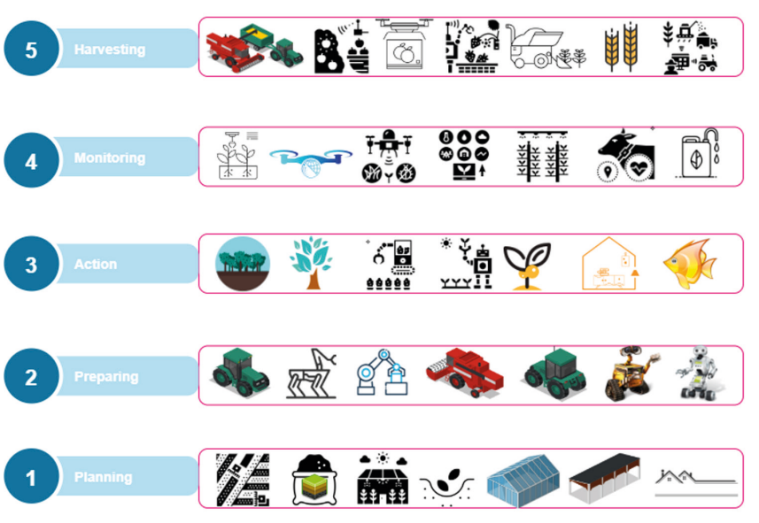
Figure 8. Conceptual farmwork of robotics in farming
  - Agribots
Agribots, also called agricultural robots, are state of the art machines designed to transform farming practices. These smart robots are equipped with advanced sensors, machine learning algorithms, and automation capabilities to carry out various tasks traditionally performed by humans. Agricultural robots serve a variety of roles in the farming industry, from harvesting apples and collecting strawberries to gathering lettuce and eliminating weeds. These technological advancements are changing the way farmers oversee and manage their agricultural operations. (V, 2021)
  - The hoeing robot
Hoeing robots in vegetable crops have the ability to autonomously remove weeds, assist farmers in weed control, and monitor plant health. They enhance profitability, environmental sustainability, and reduce manual labor, improving production economics. The data gathered can be utilized for decision-making and generating action reports. These robots utilize GPS guidance, cameras, laser technology, and electric drives, and can be remotely monitored through smartphones or tablets.
  - Vine weeding robot
This robot is specifically designed to mow grass and operates on solar energy. The area to be treated is determined using GPS coordinates and areas to avoid can be specified. Environmentally friendly, it enables a reduction in herbicide usage and can be easily controlled through a smartphone app.
  - Intelligent driverless tractors
Autonomous tractors have revolutionized the harvesting process, making it more efficient. These self-driving vehicles can be programmed or made autonomous through the use of IOT technology. Equipped with sensors, they can monitor the harvesting process and be remotely controlled. Additionally, they allow for remote data collection and analysis, enhancing their primary function.
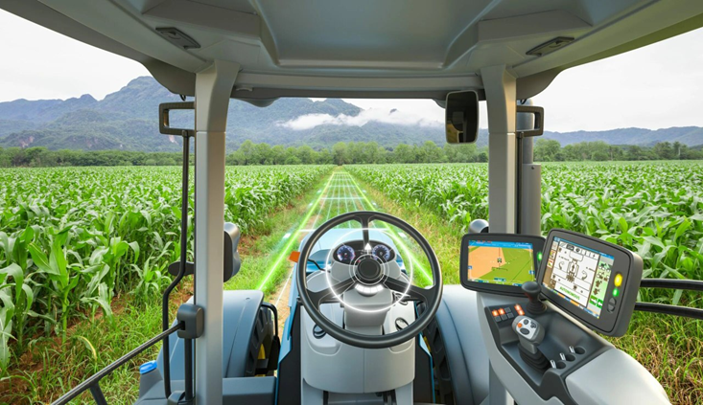
Figure 9. Intelligent driverless tractors
  - Automated greenhouses
In the realm of automated greenhouses, IoT has enabled the creation of smart farms. Atmosphere stations equipped with IoT technology can automatically adjust environmental conditions based on the specific crop. This reduces the need for human intervention, as the entire system can operate according to its own requirements. For instance, solar-powered IoT sensors are now available for various applications, collecting and transmitting real-time data on greenhouse conditions. These sensors can even send SMS alerts about water usage and greenhouse state. With the help of IoT, customized and intelligent water systems have been developed, providing information on pressure, moisture, temperature, and light levels. [17]
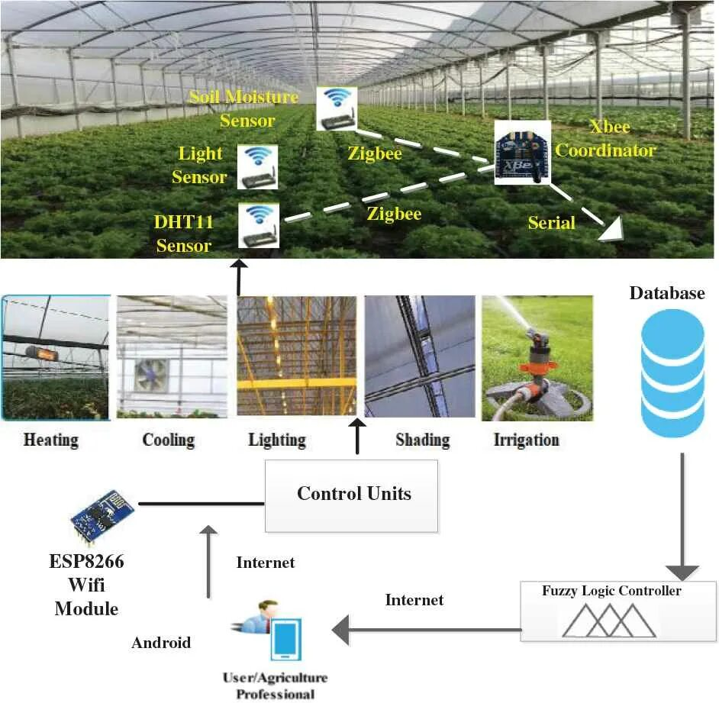
Figure 10. Automated greenhouse
  - Lawnmowers
Robotic lawn mowers are designed to trim grass without any need for human involvement. They are small and run on batteries, and thanks to advancements in artificial intelligence, they offer efficient mowing capabilities. As automation becomes more prevalent in businesses and home robots gain popularity in various domestic settings, these robotic lawn mowers are projected to experience substantial growth in the worldwide market.
- Challenges in Smart Agriculture
Implementing modern technologies in smart agriculture holds the potential to revolutionize the agricultural industry. However, integrating these technologies into traditional farming practices presents several key challenges that need to be addressed for successful adoption: [18]
- Connectivity
Ensuring reliable connectivity in all conditions, including severe weather and open spaces, is crucial for the seamless operation of smart agriculture systems. Robust connectivity is essential for the effective functioning of IoT devices, sensors, robots, and weather monitoring stations.
- Design and Durability
The design of IoT frameworks used in agriculture must be tailored to withstand the rigors of outdoor environments. Devices such as robots, sensors, and IoT gadgets need to be designed with simplicity and durability to operate effectively in agricultural settings.
- Limited Resources
Rural organizations developing IoT solutions for agriculture must navigate challenges such as rapid climate change, limited land availability, and declining pollinator populations. Adapting to these constraints requires innovative approaches to maximize resource efficiency and sustainability.
- Cost Efficiency
The cost of implementing smart farming practices can be a significant barrier, particularly in ensuring compatibility between various sensors and devices. Strategies to overcome cost barriers include simplifying device complexity, enhancing data transfer capabilities, and leveraging data analytics to transform raw data into actionable insights.
Digital technologies in agriculture offer opportunities for improvement and advancement across economic, social, and environmental dimensions:
- Economic Impact Technology can boost productivity, reduce logistics costs, minimize wastage, expand market opportunities, enhance sustainability, and optimize value chains in agriculture.
- Social and Cultural Influence Technological advancements can foster social and cultural engagement within agricultural communities, promoting participation and collaboration.
- Environmental Sustainability Smart, precision, and digital agriculture enable monitoring, optimization of agricultural processes, value chains, and product delivery. These technologies support environmental conservation, adaptation to climate change, and efficient utilization of natural resources.
By addressing these challenges and leveraging the potential of digital technologies, smart agriculture can drive innovation, sustainability, and resilience in the agricultural sector. [19]
- Conclusion
In final thought, IoT in farming assures improved performance plus durability. With accuracy farming animals surveillance as well as provide chain monitoring, farmers can access real-time information to enhance their procedures. In spite of obstacles, the prospective advantages are tremendous revolutionizing farming for an extra thriving plus lasting future.

Chapter Ⅲ

- Introduction
We have always wanted to serve the people of this world. The motivation for the Lawnmower named “NIMO” came from watching surrounding people doing difficult household chores on their own, putting so much efforts on some works, especially old and disabled people. To minimize their efforts, we thought of combining available devices or machines with IOT (IOT). IOT is a platform which gives us opportunity to change working way of a system by taking all the controls in our hands. A technology which is being used in many of the today’s applications and use of which is increasing rapidly on daily basis.
In this technology many embedded systems, different sensors work together other and interact with each other using internet and information exchange is done through a wireless network. Many problems are solved using IOT technology. Major advantage of IOT technology is it provides real time solutions for the given problems. So, we used current lawn mower system and made it user friendly by making it fully controllable and easy to use so user
- Project Objective
Our Arduino-Based Robotic Lawn Mower project aims to create a lawn mower that addresses the key challenges faced by homeowners and gardeners in maintaining their outdoor spaces. The primary objectives of This Project are:
- Develop a User-Friendly Automatic Lawn Mower.
- Ensure Comfort and Ease of Use.
- Achieve Cost-Effectiveness and Efficiency.
- Leverage Emerging Technologies.

- Arduino and Proteus Integration
In our project, we used Proteus and Arduino as vital software tools to empower the functionality and control of our Arduino-based robotic lawn mower. [5]
Arduino is an open-source electronics platform based on easy-to-use hardware and software, enabling creators to develop interactive objects and projects. Proteus, on the other hand, is a simulation and design software suite widely used for electronic circuit design, simulation, and PCB layout. Integrating these tools was instrumental in realizing the capabilities of our robotic lawn mower system.
- Below are the detailed steps we followed to bring our robotic lawn mower to life, from setting up the environment to simulating and testing its performance:
- Setting Up Proteus and Arduino IDE

We began by installing Proteus Professional on our computer and downloading the Arduino IDE.

- Designing the Circuit in Proteus:
Opening Proteus, we created a new project to start building our robotic lawn mower's circuit.
Adding an Arduino Uno board to the workspace, we carefully placed it in the circuit drawing area.
Integrating components such as motors, sensors (like an ultrasonic sensor for obstacle detection), motor drivers, and other necessary electronic parts completed our circuit design.
- Connecting and Configuring Components:
We utilized the wire tool in Proteus to connect the components according to our circuit design specifications.
Configuring pins, inputs, and outputs for sensors, motor control, and other functionalities was an essential step in ensuring seamless integration.

- Writing Arduino Code
Moving into the Arduino IDE, we delved into writing the code to control our robotic lawn mower.
After writing the code, we verified and compiled it in the Arduino IDE to check for any errors or inconsistencies.
- Uploading Code to Proteus Arduino

With the code compiled successfully, we proceeded to upload it to the virtual Arduino in Proteus. This involved:
- Double-clicking on the Arduino component in Proteus to access its properties.
- Selecting the .hex file generated by the Arduino IDE after compiling our code.
- Uploading the code to the virtual Arduino board within the Proteus environment.
  - Simulating and Testing
Executing the simulation in Proteus allowed us to observe firsthand how our Arduino-based robotic lawn mower behaved. This crucial step enabled us to validate our code and circuit design.
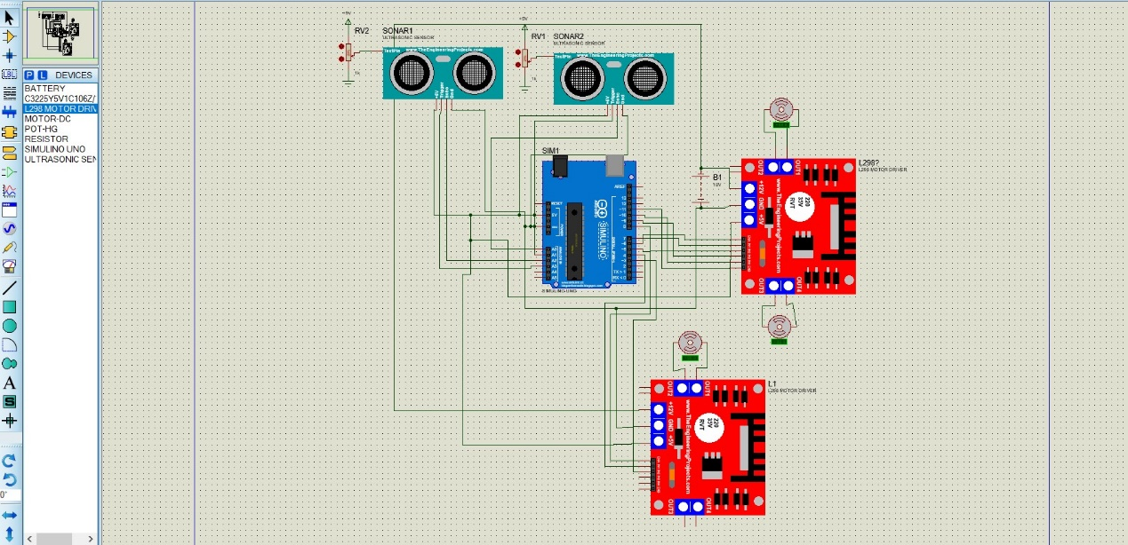
Figure 11.lawnmower simulation
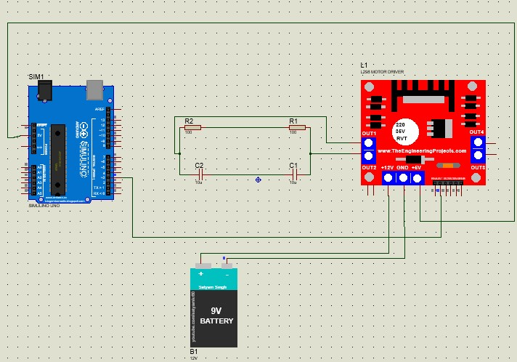
Figure 12.primeter station simulation
For the cut motor we decided to use a relay instead of a L298N motor driver here is the simulation in Proteus
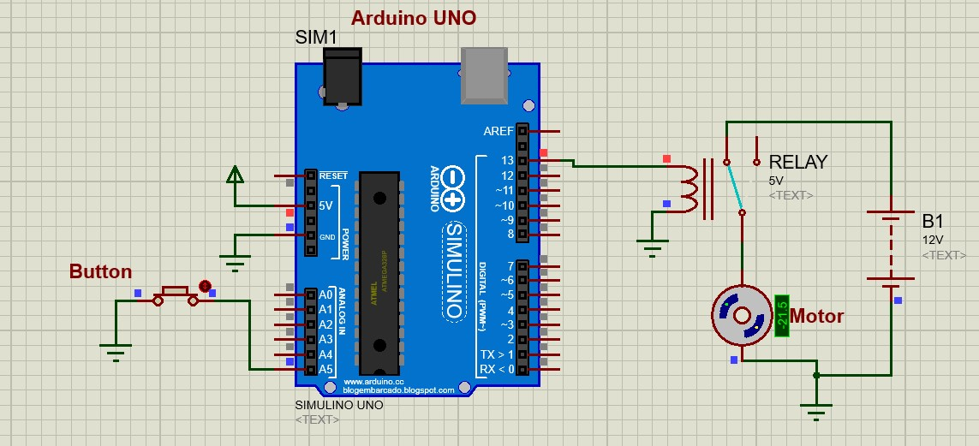
Figure 13. Relay simulation

After successfully simulating our smart lawn mower project in Proteus, we felt confident about our design. The simulation showed us that all the parts worked well together. Because of this, we decided to turn our virtual project into a real one. We used these Proteus schematics to build our actual lawn mower, including the Arduino, sensors, motors, and other hardware.

- Proposed Design
The proposed design of the robotic lawn mower aims to combine efficiency, durability, and ease of use. It consists of a robust physical structure, carefully selected components, and advanced functionalities to ensure effective lawn maintenance.
In the third chapter of our proposal, we have concentrated on creating through Blender software the chassis, cutter and body meant for the lawnmower robot. The inspiration came from other robotic lawnmower projects that exist and how efficient household cleaning robots are made therefore we had to make sure each part meets the strict requirements necessary in outdoor maintenance.
Chassis being a durable and stable engineering design is the basis of stability of the robots making it work smoothly even over rough grounds. It has advanced blades as
well as cutting mechanisms which allow for precise grass cutting to increase performance as well as minimize energy consumption. 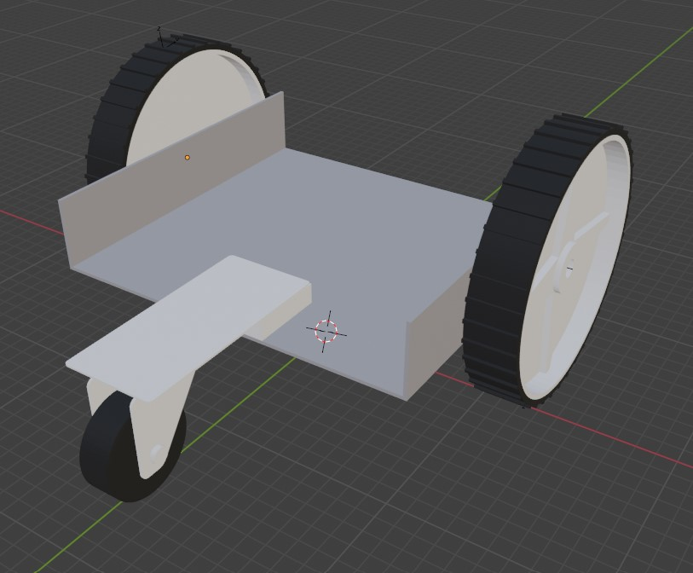
Figure 14.chassis design
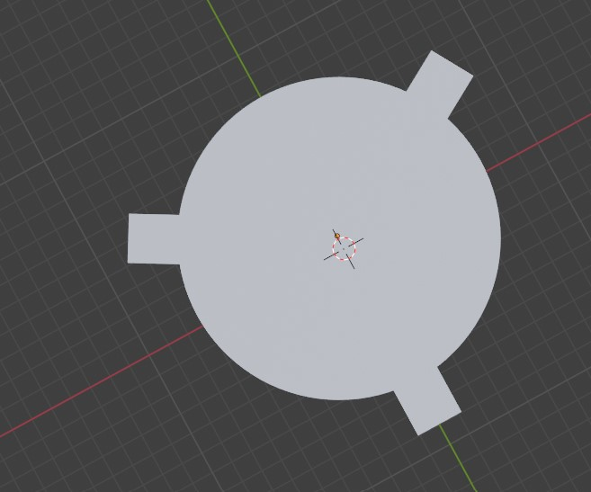
Figure 15.cutter design

In addition, its streamlined body design complements functionality by emphasizing weather resistance and user-friendly features thereby improving aesthetics and practicality at the same time. This project aims through innovative design and engineering methods to transform lawn care into self-autonomous, effective and environmentally friendly solutions.
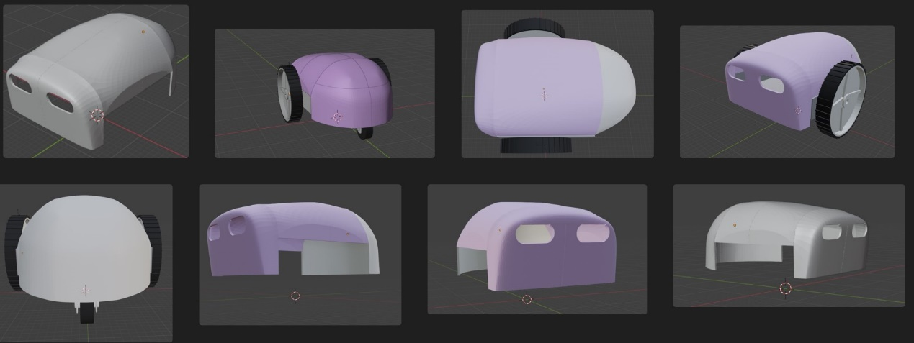
Figure 16. lawnmower design

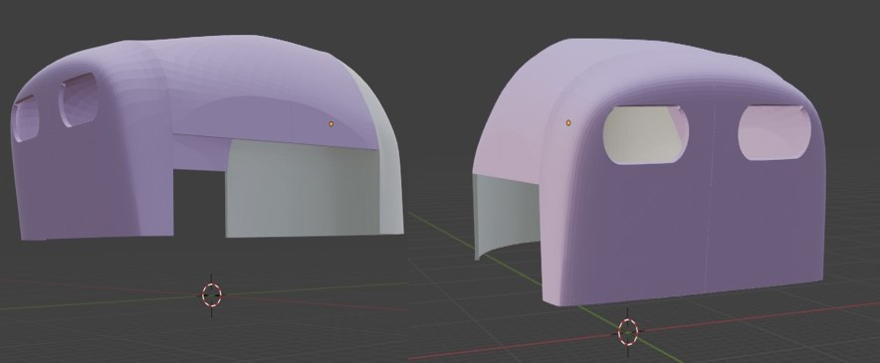
Figure 17.body design
Front plate and the ultrasonic sensor holder (Easel)
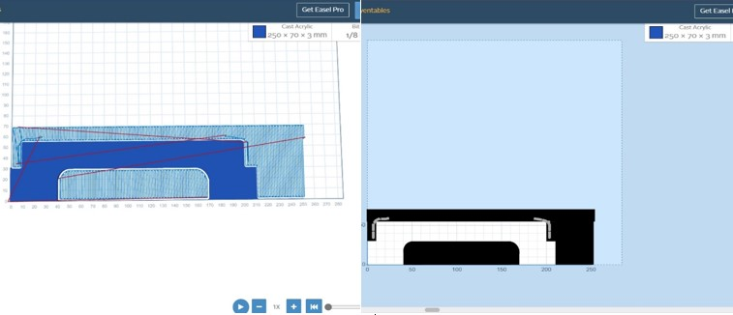
The front plate is cut out of 3mm clear acrylic and it is used to mount the two perimeter sensors and to stop cut grass from entering the robot body.
Figure 18. Front plate design
the ultrasonic sensor holder is Crafted with precision and durability in mind, this holder provides a stable platform for mounting ultrasonic sensors, ensuring accurate readings in various applications.

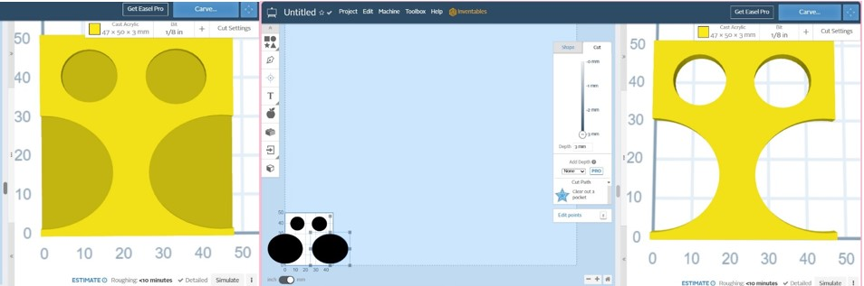
Figure 19. Ultrasonic sensor Holder
designing is a crucial step in bringing any project to life, making it more tangible and realistic. It allows you to visualize your ideas, identify potential challenges, and refine your concept before moving forward with implementation. Plus, it helps communicate your vision effectively to others involved in the project.
- Methodology
  - Project Materials :

Components |  | Description
DC motor 12V | 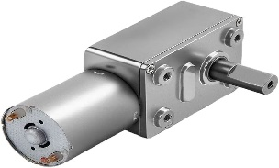 | A specialized motor designed to provide high torque output at low speeds, ideal for driving the propulsion system of the robotic lawn mower.
DC 12-24V RS-750 motor | 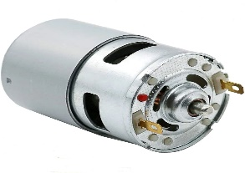 | A versatile motor with a wide voltage range, suitable for various applications within the mower's mechanical system, such as blade rotation or auxiliary functions.
Arduino uno | 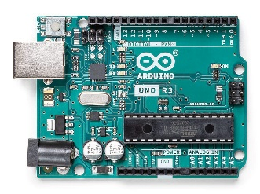 | The central control unit of the robotic lawn mower, responsible for processing sensor data, executing algorithms, and coordinating motor movements.
Ultrasonic sensor | 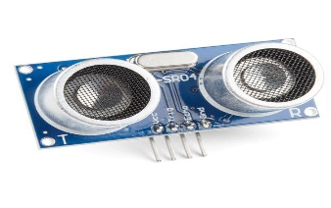 | Detects obstacles in the mower's path by emitting high-frequency sound waves and measuring the time taken for them to bounce back, enabling effective navigation and obstacle avoidance.
Jumper wires | 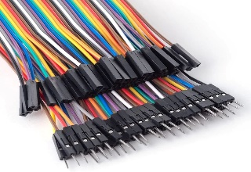 | Provide flexible electrical connections between components on the breadboard or within the system, facilitating prototyping and circuit assembly.
Bread board | 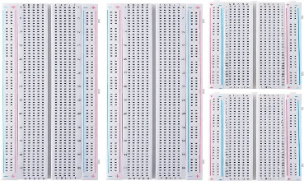 | A reusable platform for prototyping electronic circuits, allowing components to be easily connected and rearranged without soldering.
Resistors | 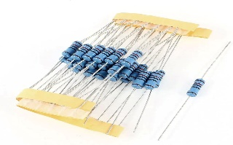 | Control the flow of electrical current within circuits, serving various functions such as voltage division, current limiting, and signal conditioning.
Lithium Batteries | 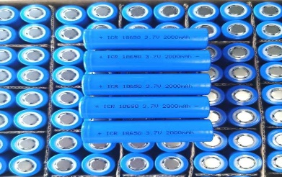 | Provide electrical power to the robotic lawn mower, offering high energy density and rechargeable capability for extended operation.
DC Converter | 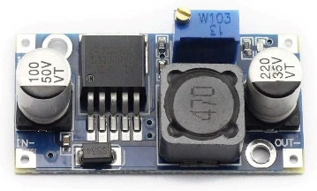 | Converts input voltage to the required level for specific components or subsystems, ensuring compatibility and efficient power utilization.
L298N motor driver | 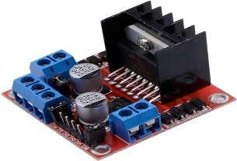 | Controls the speed and direction of DC motors, translating input signals from the Arduino into motor movements for precise control.
Copper strip board | 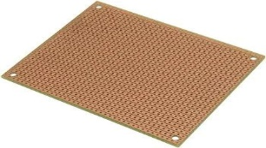 | Provides a platform for soldering electronic components and creating custom circuits, offering durability and reliability in harsh operating environments.
LM358 operation amplifier (OPAMP) | 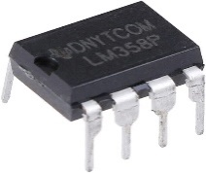 | Amplifies and processes analog signals from sensors or other sources, enabling accurate measurement and control within the mower's system.
Cutting Blades | 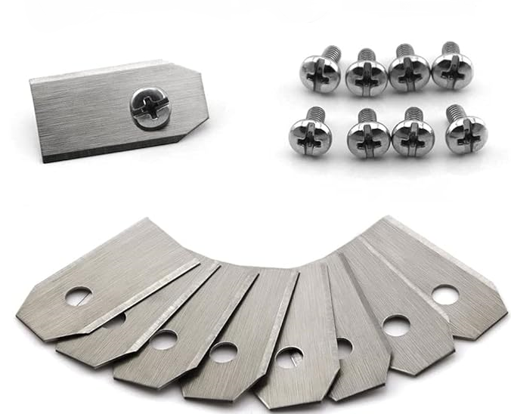 | Mounted on the mower's chassis, these blades efficiently cut grass to maintain desired lawn height, ensuring effective lawn maintenance
Box Holder | 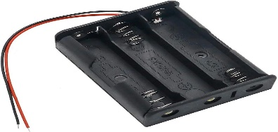 | Securely mounts electronic components or subsystems within the mower's enclosure, protecting them from environmental hazards and mechanical stress.
Wheel with Brake | 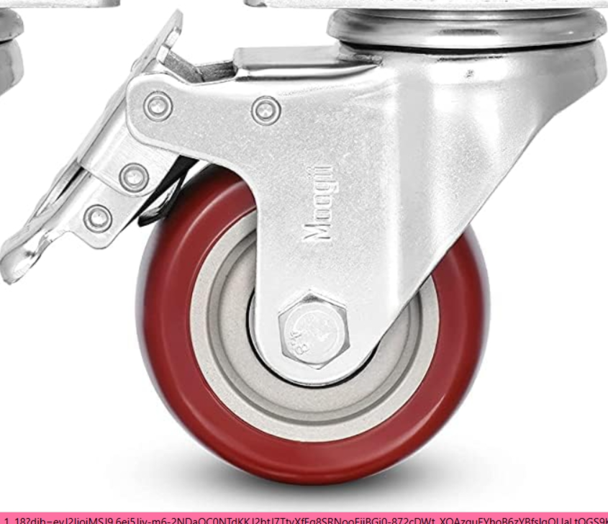 | Equipped with a braking mechanism, these wheels provide traction and stability while allowing precise control over the mower's movement and stopping.
Wheel | 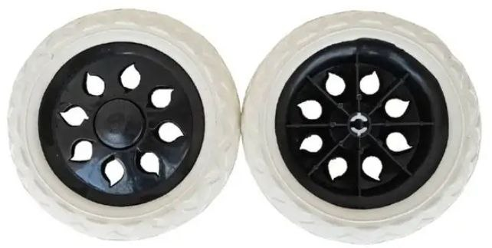 | Support the weight of the robotic lawn mower and facilitate movement across various terrains, with considerations for traction, durability, and load-bearing capacity.
Capacitors | 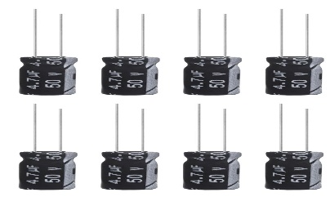 | passive electrical components, store energy in an electric field between two conductive plates when a voltage is applied across them
Inductors | passive electrical components store energy in the form of a magnetic field when an electric current flows through them
Table 4.Part List
  - Making parts
all the parts were made by my dad “Lokman Boukedjar”
If you're building your own robot, consider making custom parts to maintain a streamlined design Below is a list of parts my dad made for the robot, I've given a step-by-step guide on how they were made and what techniques were used
    - Chassis
The objective was to develop a straightforward robot chassis that could serve as a solid foundation for navigating rough terrain while maintaining a lightweight structure.
Material Selection: we choose a 2.0mm thick aluminum plate for the chassis as the primary material for its lightweight,
Cutting and Shaping: we cuted an aluminum plate that was 27 x 190x 0.2 cm, then he bended 35 mm from the edge to create chassis sides for mounting the DC motors.
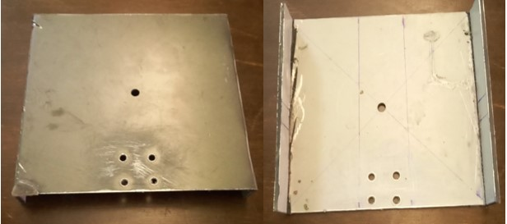
Figure 20.chassis
then we add a wheel with brake and the wheels
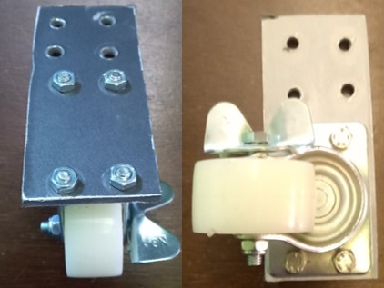

Figure 21.wheel with brake
Unfortunately, the motor came without the gears and its shaft was too small to fit it into the chassis with the wheel, so we needed to find a solution. We decided to have these parts made by a machinist. It took longer than expected, but in the end, it worked well.
    - Body
For the body, we have already designed it using software called Blender. Then, my father created a mold with gypsum. Once the mold was completely dry, we poured resin into it. After letting it dry, we demolded it to obtain the shell of our lawn mower.
I began by hand-sanding the entire body of the object using 180-grit sandpaper. After the initial sanding, I followed up with 240-grit sandpaper to further refine the surface. Once the sanding was complete, I sprayed the body with paint.
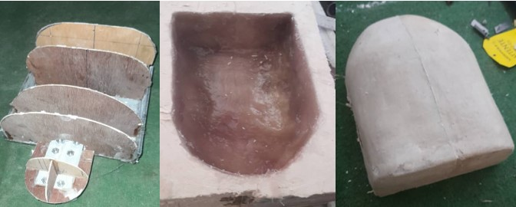
Figure 22. steps body construction
    - Cutter
The cutter comprises a 13cm diameter round stainless-steel disc, with the DC cutting motor positioned at the center of the chassis base plate. Initially, I drilled a 15mm hole for the shaft mount, followed by two holes for the M3 screws to secure the motor to the chassis.
The cutting disc is affixed to the motor shaft. Ensuring the hub mount is precisely centered is crucial to prevent vibrations during operation. Additionally, the disc must be meticulously balanced. Therefore, it is essential to position the blade holes 120 degrees apart from each other, equidistant from the disc edge. Utilize locknuts to secure the blades and prevent them from loosening or becoming dislodged.
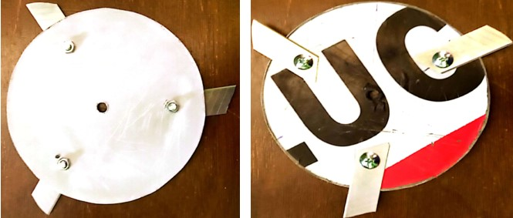
Figure 23.cutter
    - Front plate
The front plate serves an important purpose in the design of this robot. Here are the key details:
Materials and Construction
The front plate is made of 3mm thick clear acrylic material.
Mounting and Protection
The plate is used to mount the two perimeter sensors on the robot.
It also helps to prevent cut grass from entering the main robot body during operation.
By using a clear acrylic material and strategically placing it on the front of the robot, the design allows the sensors to function effectively while also protecting the internal components from debris. This thoughtful integration of the front plate contributes to the overall reliability and performance of the robot.
- Schematics
This is the schematics for the motor controller front wheels
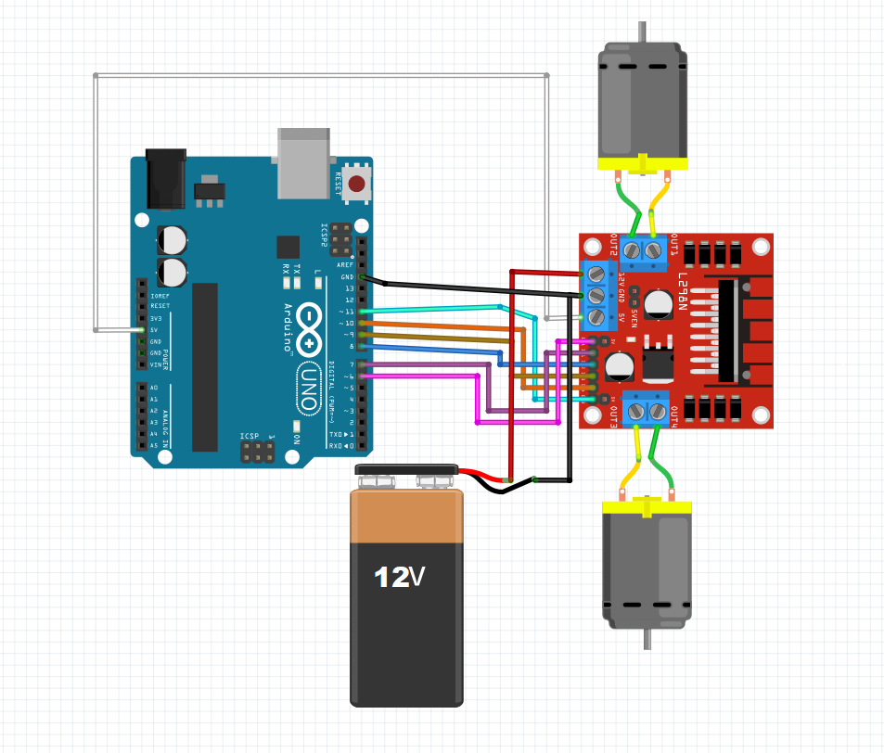
Figure 24.motors schematic
This is the schematics for the two ultra sound sensors on the robot
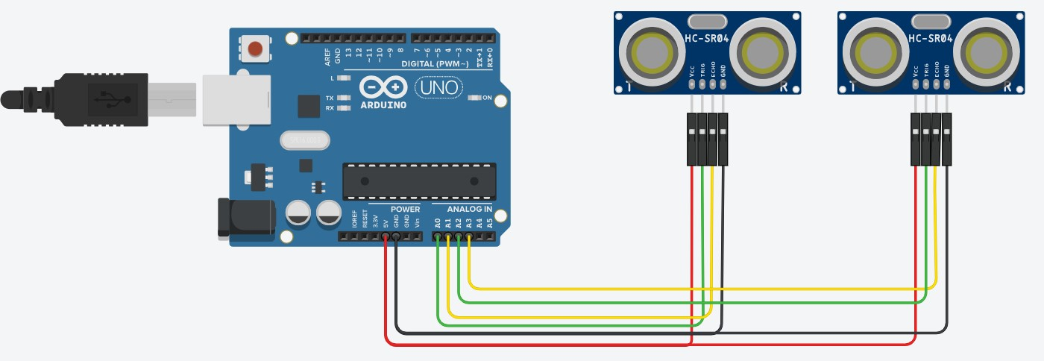
Figure 25.ultrasonic sensors schematic
This is the schematics for the motor controller cutting motor
This is the schematics for the perimeter sensor amplifier
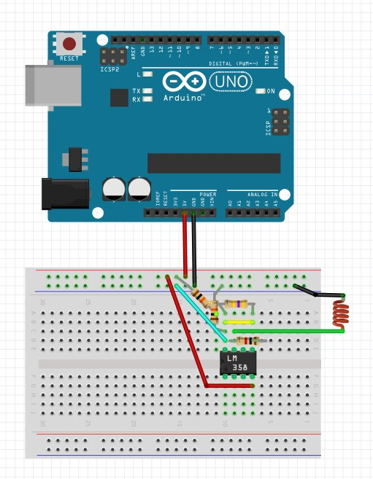
Figure 26. fence sensor schematic
This Schematics for the perimeter wire station
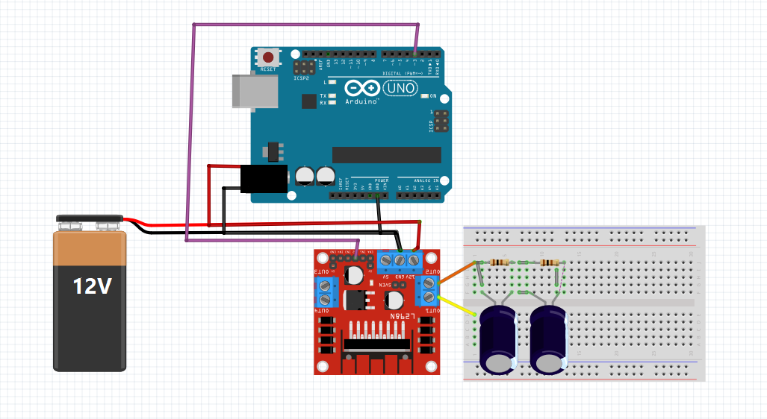
Figure 27. perimeter station schematic
- Source Code
Our system is mainly based on Arduino system. Arduino application is running on processed in C code language. Two codes were written, separately one for the control on the lawnmower mower and the second for the station. As follows, we are able to point out the main segments of the code:
1st Code
Include Libraries:

This library allows using Arduino functions
- Global Variables and Definitions
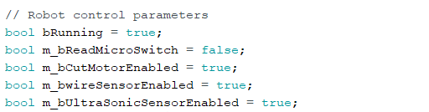
These are Boolean variables defining various states and settings of the robot·
int variables: Pin assignments for motors, sensors, buttons…
- Setup Function (void setup ())
Configures pins for input/output and initializes serial communication·
Initializes interrupts for speed sensors·
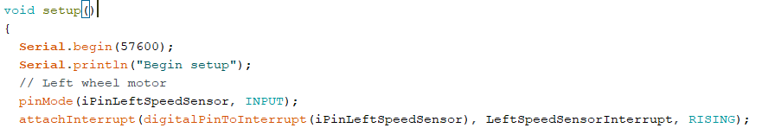
Configures ADC for reading analog sensors·
Sets up pins for motor control and ultrasonic sensors·
- Motor Control Functions
Functions like forward ()
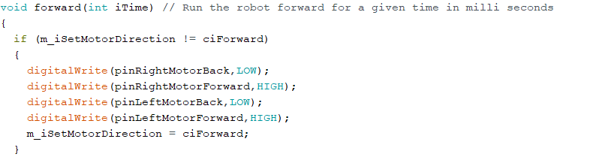
turn Right (), stop (), etc.…
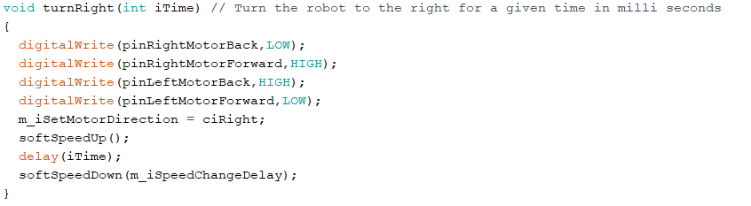control the movement of the robot by setting motor pins accordingly· These functions adjust motor speed using PWM·
- Sensor Reading Functions
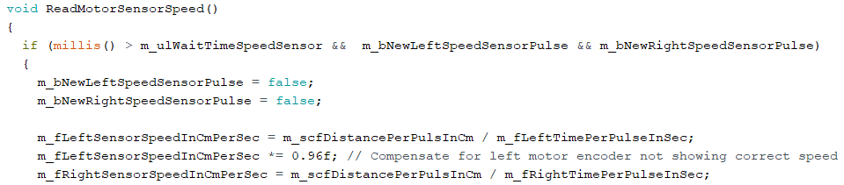Reads speed sensors attached to motors
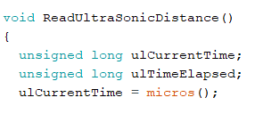
Reads data from ultrasonic sensors·
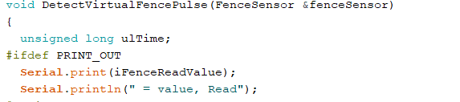
Detects pulses from virtual fence sensors
- Interrupt Service Routine (ISR)
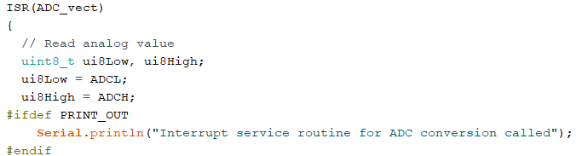Handles ADC conversions for reading analog sensor values·
- Utility Functions
soft Speedup (), softSpeedDown (): Smoothly adjusts motor speed·
AddSensorWaitTimeWhenSpeedingUp (): Sets up wait time for sensor reading·
- Main Loop
The main loop handles back-off maneuvers, reads sensors, and performs corresponding actions based on sensor inputs·
It's designed to handle various scenarios such as obstacles, speed adjustments, and virtual fencing
2^{nd Code}:
int iPinPulse = 3; This line declares an integer variable iPinPulse and initializes it with the value 3. This likely represents the pin number where a pulse will be generated.
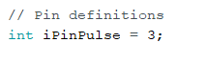
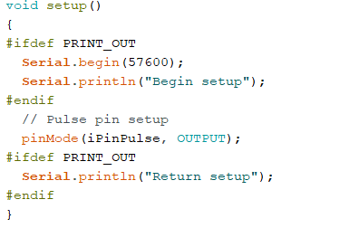
This function is called once when the microcontroller starts. It is used for initializing variables, pin modes, libraries…
Serial. Begin (57600) This line initializes serial communication with a baud rate of 57600 bits per second.
pin Mode (iPinPulse, OUTPUT); This line configures pin iPinPulse as an output pin. This pin will likely be used to generate a pulse.
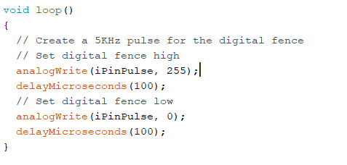

- analog Write (iPinPulse, 255); writes a PWM (Pulse Width Modulation) value of 255 to the pin specified by iPinPulse. This will set the pin to its maximum value, typically representing a digital high.
- delay Microseconds (100); pauses the program execution for 100 microseconds. This delay is introduced to control the duration of the pulse.
- analog Write (iPinPulse, 0); writes a PWM value of 0 to the pin specified by iPinPulse, setting it to its minimum value, typically representing a digital low.
- delay Microseconds (100); This line introduces another 100 microseconds delay.
Overall, this code sets up a pulse on a specific pin (pin 3) of the Arduino board, with a frequency of approximately 5 kHz.
- Final Preliminary Study
After a bunch of tries, we finally got our lawn mower working. It was a big moment when it actually moved on its own. This project took a really long time. We had to swap out the second motor driver for a relay to control the cutting motor.
Gluing, taping soldering painting . . . it was a process, and we definitely screwed up a few times before getting it right.
The middle motor was just too powerful. We realized a regular motor driver would damage our Arduino, so we went with a relay instead to turn down the power. And since we changed hardware, we obviously had to tweak the code too
Below, we will show you images of the final part of the project:
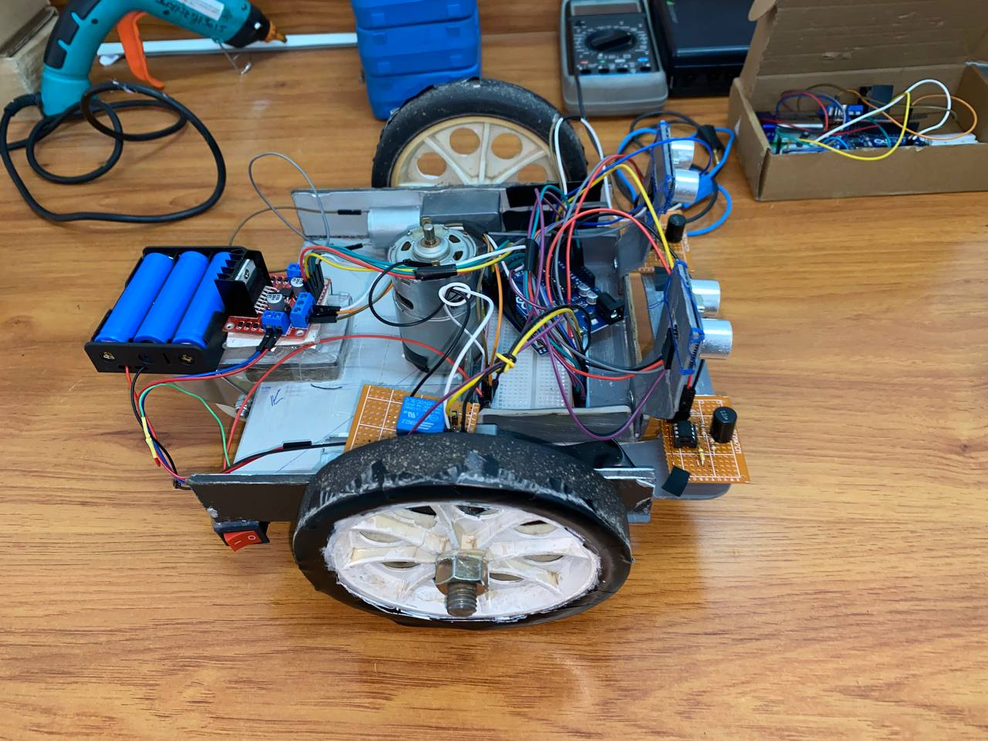
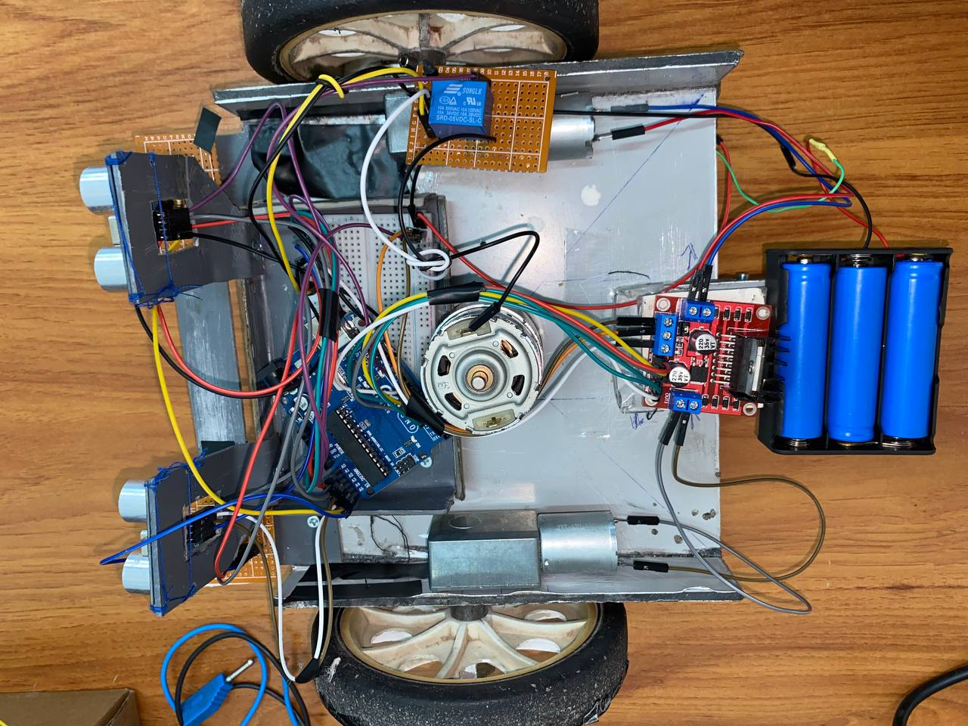
Figure 28.final Chassis
Note: In this image, everything went well, so we decided to put all the components in place and solder the wires with the motors and the battery.
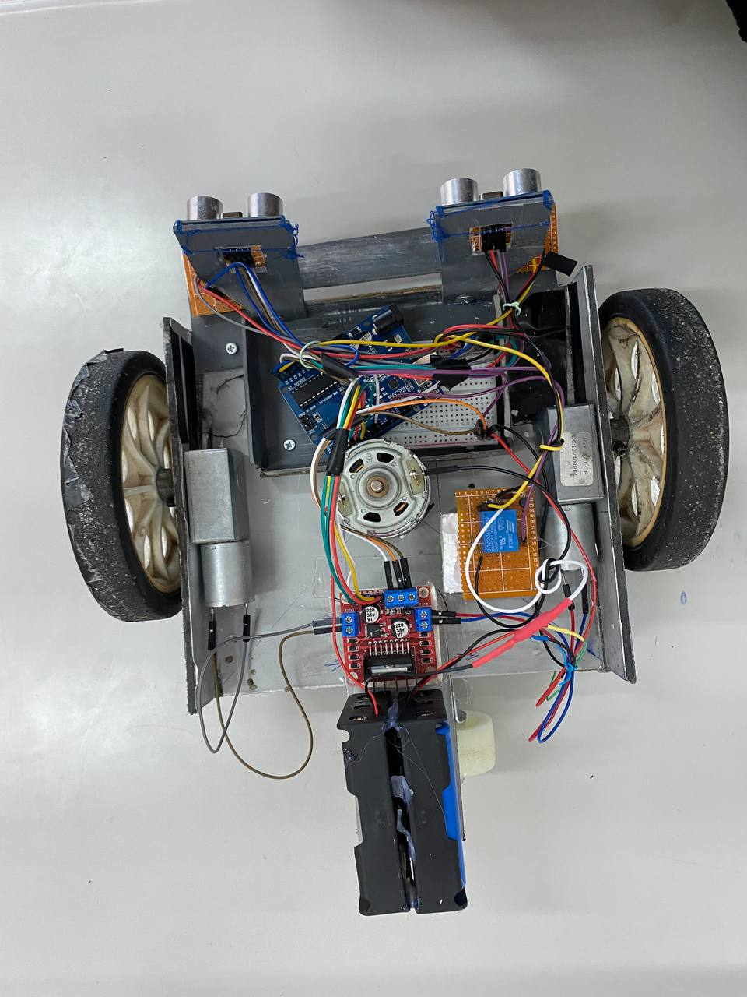

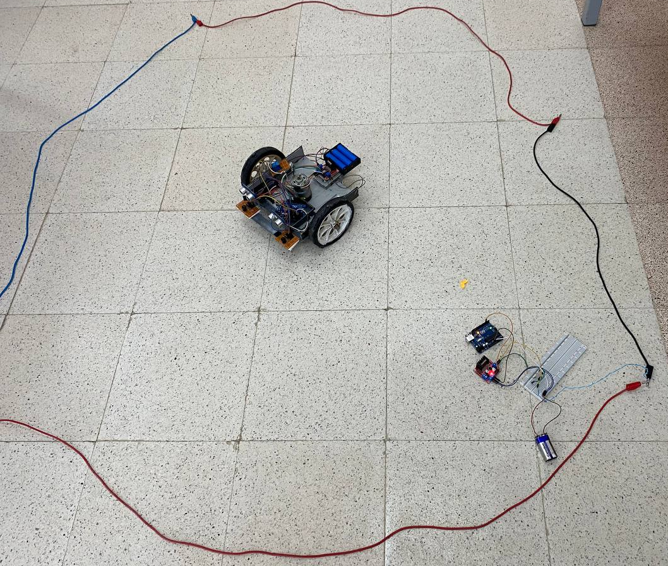
Figure 29. Final perimeter station
note: This is the ultimate perimeter station where you can define the boundary for the lawnmower area
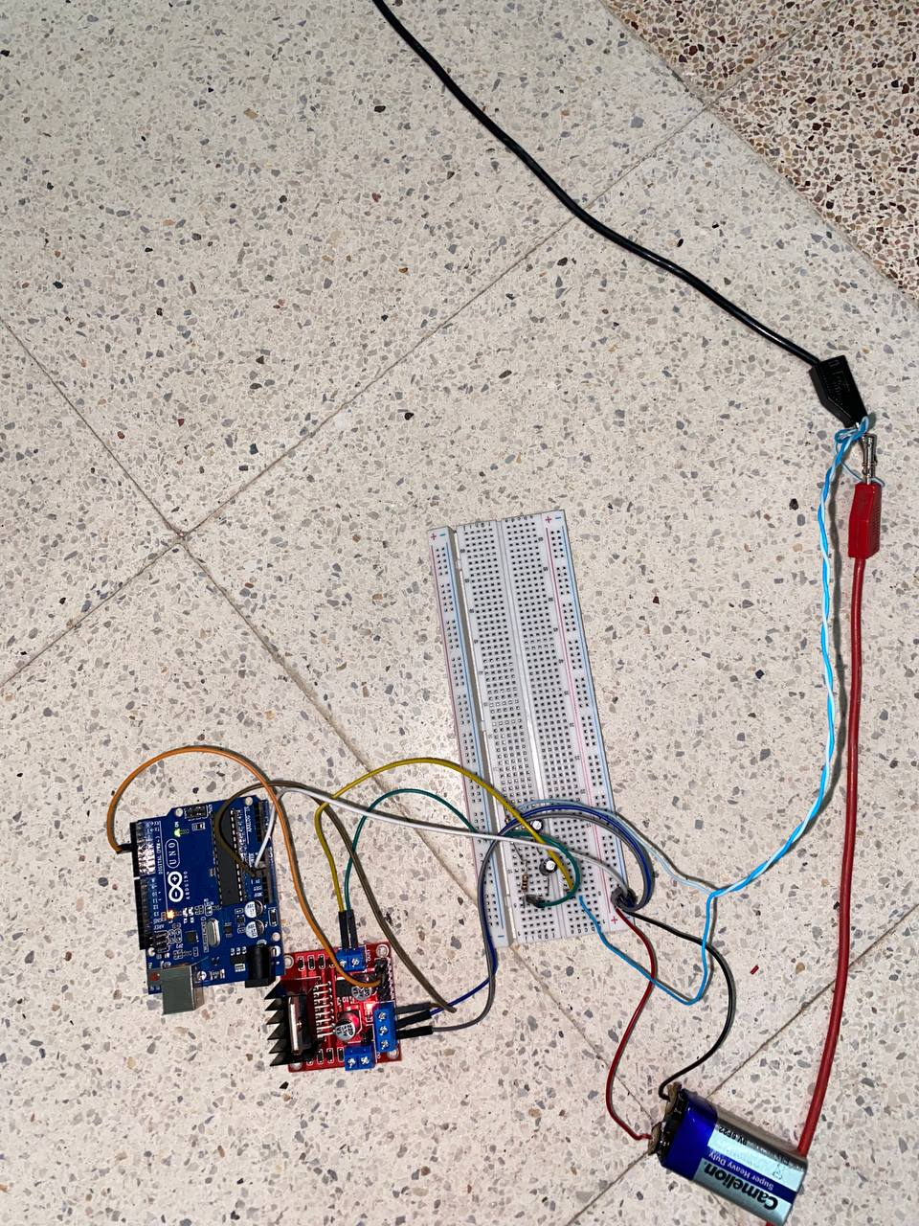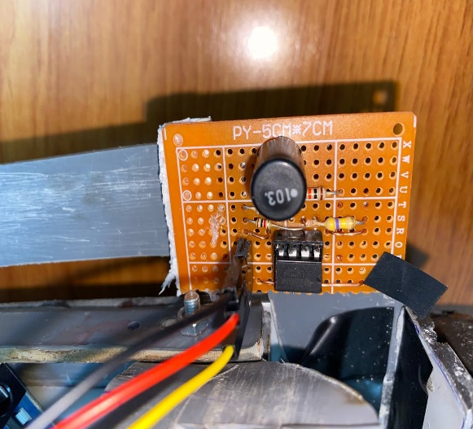
Figure 30.fence sensor
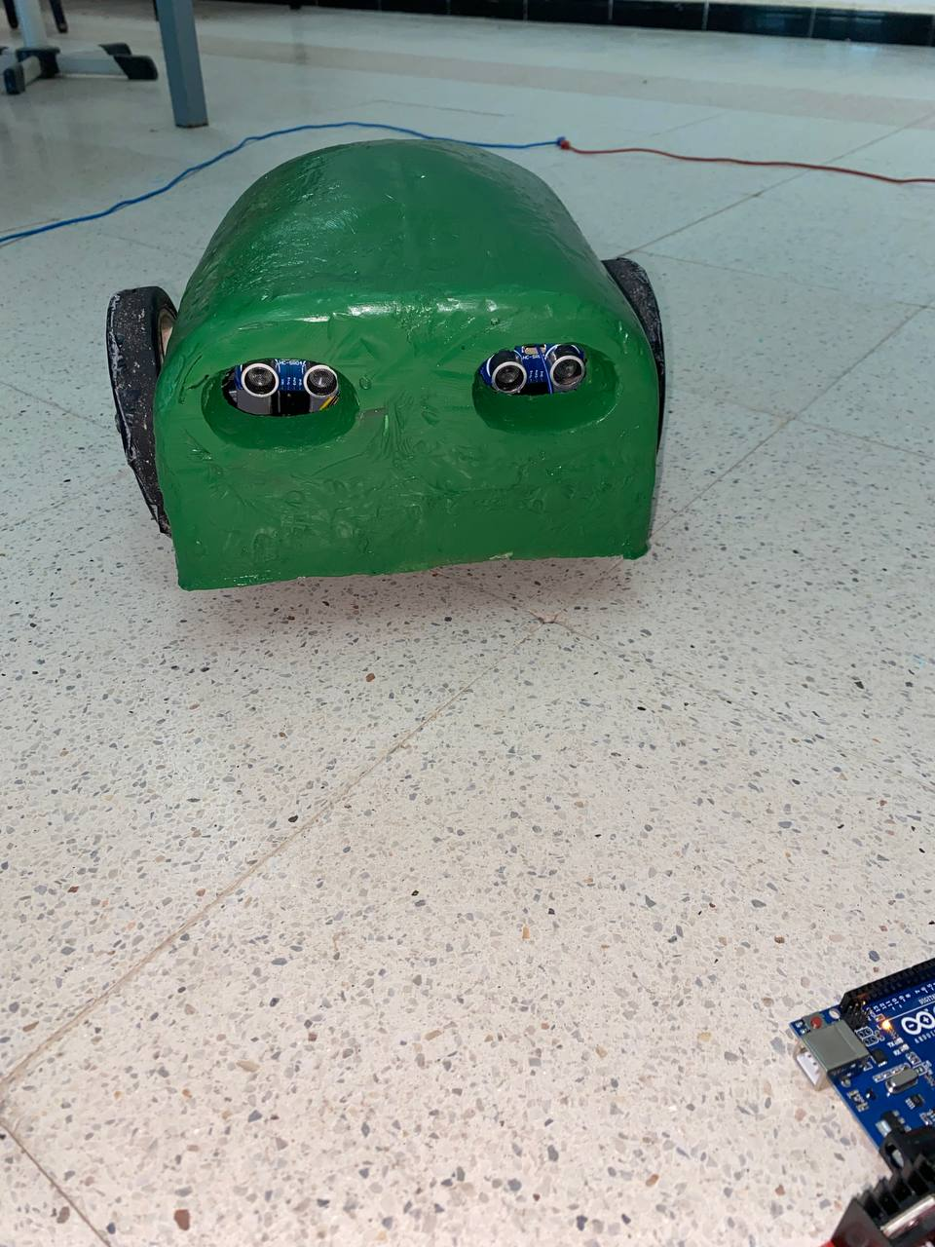
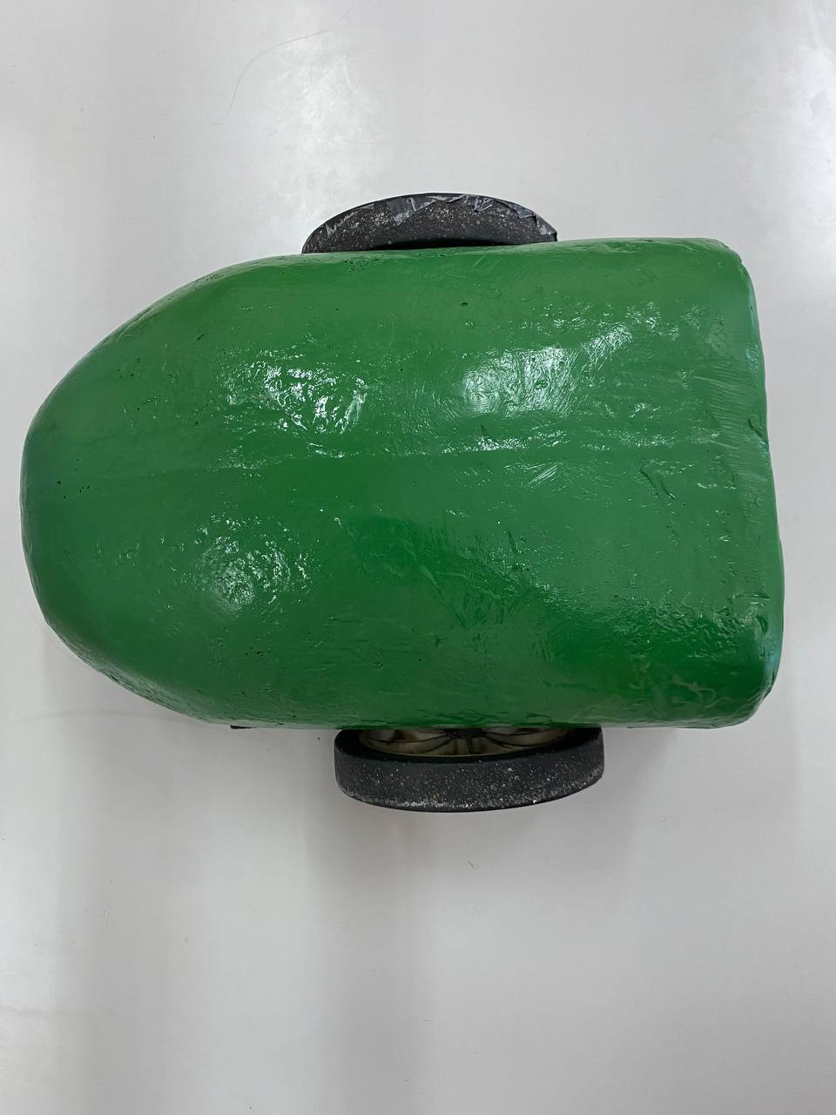
Note: This is how the final body shape appears, as we discussed earlier, after painting and attaching it to the chassis.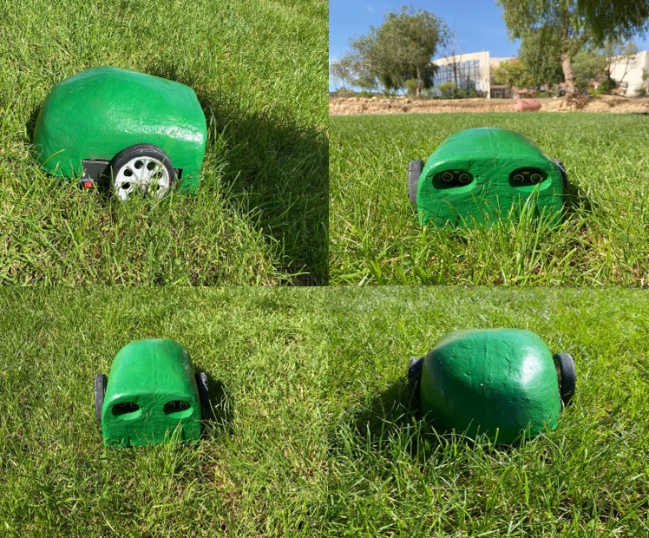
Figure 31.lawnmower
Result: Here is what our smart lawnmower looks like. We tested it on the grass to confirm that it cuts perfectly and successfully avoids any obstacles.

  - Recommendations and Future Work
Unfortunately, as a result of time constraints, we did not make much progress, so we are simply pushing it forward as a suggestion and something to aspire towards.
solar panel
Implementing charging using solar panels for a lawn mower makes a lot of sense considering it is being used in open areas and much more sustainable.
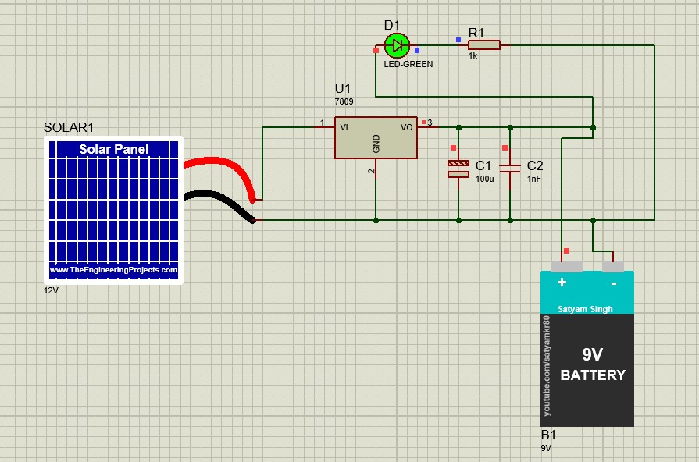
Figure 32.Solar panel
We used proteus for the charging solar panel Simulation
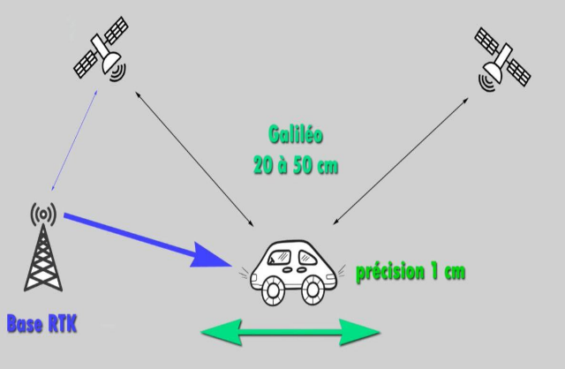
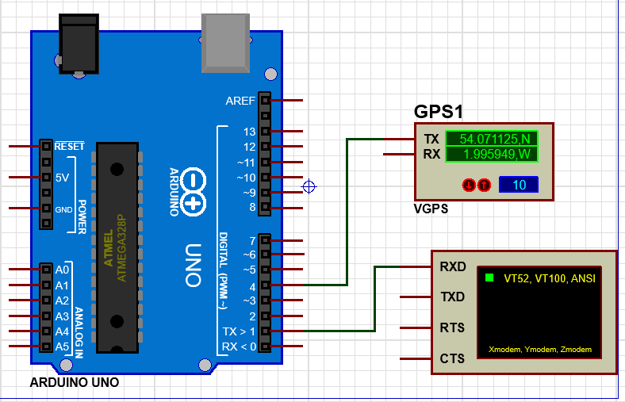
GPS RTK (Real Time Kinematics)
Figure 33.GPS RTK
is a differential GNSS technique which provides high positioning performance in the vicinity of a base station. The technique is based on the use of carrier measurements and the transmission of corrections from the base station. [20]
  - Issues and requirements
As any project that deals with deployment of hardware and software, we faced some issues during the implementation of our project we can mention some of them in order to get some lessons and experiences
• Tools and hardware components availability
When we decided to start the realization of the IoT network we found ourselves very limited by the available hardware in the Algerian market which is still in the beginning and also the high pricing comparing to other international markets
• Battery
In addressing the battery aspect of our project, we encountered limitations in the available options. Consequently, we opted for lithium batteries due to their rechargeable nature, albeit primarily for experimental purposes.

- Conclusion
In conclusion the third chapter of our master’s thesis focused on detailing the creation and design process of our Arduino Based Robotic Lawn Mower. Through the use of Blender, Proteus and Arduino to develop and integrate components our goal was to revolutionize lawn care by making it more efficient and user friendly. Despite facing challenges such, as hardware constraints, our systematic approach and unwavering commitment ultimately yielded outcomes...
Looking forward potential enhancements such as incorporating panels for eco charging hold promise for progress. Despite obstacles encountered during the project it demonstrates how technology can simplify tasks and improve accessibility, in the field of automated lawn maintenance.

Appendix
Software Used
Arduino IDE
The Arduino Integrated Development Environment (IDE) is a cross-platform application (for Windows, macOS, Linux) that is written in functions from C and C++. It is used to write and upload programs to Arduino compatible boards.


Proteus
Proteus is a software tool used for electronic circuit design, simulation, and PCB layout. Proteus allows users to simulate both analog and digital circuits, including microcontroller-based systems, making it suitable for a wide range of applications. Additionally, Proteus offers a user-friendly interface and extensive component libraries, making it a popular choice among electronics engineers and hobbyists alike for developing and prototyping electronic projects.


Blender
Blender is a powerful and versatile open-source 3D creation software. Blender is widely used by professionals and hobbyists alike for creating stunning visual effects, animations, video games, and architectural visualizations. With its active community and frequent updates, Blender continues to evolve, providing artists with cutting-edge tools for bringing their ideas to life in the digital realm.

Fritzing
Fritzing is an open-source software tool used for designing electronic circuits, especially for creating schematics, PCB layouts, and breadboard views. Fritzing supports a wide range of components and allows users to create custom parts.


Circuit.io


Circuit.io, now known as Tinker cad Circuits, is an online platform for designing and simulating electronic circuits. Tinker cad Circuits supports a wide range of components, including microcontrollers, sensors, and actuators, making it suitable for both beginners and experienced electronics enthusiasts. Tinker cad Circuits also integrates seamlessly with other Autodesk products, providing a comprehensive solution for electronics design and prototyping.

Easel
Easel is a web-based software platform developed by Inventible, primarily used for designing and generating toolpaths for CNC machines. Easel supports a variety of CNC machines, including those for woodworking, carving, and engraving. Additionally, Easel provides integrated access to Inventible' library of materials and carving projects, making it a valuable resource for both beginners and experienced CNC users.


Easel

GENERAL CONCLUSION

In conclusion, this master’s thesis explores the transformative power of the IOT, which crosses over into a variety of different fields, with a focus on agriculture. In this paper, we have discussed how IoT in general more precisely, smart farming unfolds a wide range of new possibilities for effective management and decision-making within agricultural practices.
The implementation of the smart lawn mower project is the end result of our work, whereby we intend to use technology for the implementation of practical solutions. By integrating IoT principles seamlessly, we have managed to make a device that eases physical stressors aside from lawn maintenance and proves the potential to connect systems in order to simplify everyday tasks.
Our journey captured in this master’s thesis testifies to the transformational power of the IOT in redesigning human environment interaction, ensuring a future where innovation and connectivity redefine how we interact with the world around us. This will stand as a shining example to demonstrate how technology can be leveraged to provide tangible benefits for individuals and communities alike.

- References

[1] | P. Pedamkar, "EDUCBA," 29 MAY 2023. [Online]. Available: https://www.educba.com/iot-features/.
[2] | "GeeksForGeeks," 23 january 2023. [Online]. Available: https://www.geeksforgeeks.org/architecture-of-internet-of-things-iot/.
[3] | L. Abdelhak, "Internet of Things based on," p. 74, 23 juin 2018.
[4] | " What are the Components of IoT," [Online].
[5] | Z. Dafri, «Réalisation d'un système basé sur Internet des,» p. 55, juillet 2019.
[6] | M. Malika et M. Nabila, «Internet des objets dans le domaine de demain,» p. 91, 29 septembre 2019.
[7] | D. S. V. Viraktamath and B. B. Shankaranand , "A Comprehensive Review on IoT and Its," vol. 9, August 2021.
[8] | M. AYAZ, A.-U. MOHAMMAD , S. ZUBAIR , M. ALI and M. A. EL-HADI , "Internet-of-Things (IoT)-Based Smart Agriculture:," vol. 7, 1 august 2019.
[9] | B. Bilal and L. Dounia, "A solution for managing firewalls in the Internet Of Things," 2020/2021.
[10] | K. Sofiane and A. Ismail, "Conception et réalisation d'un système d'agriculture," p. 40, 2017/2018.
[11] | F. H. Masmali, J. M. Shah and . N. Nasimul, "Different Applications and Technologies of Internet of Things (IoT)".
[12] | D. M. B. N. R. R. P. A. J. D. Mavaluru, "INTERNET OF THINGS (IOT):SYSTEMS AND APPLICATIONS," 978-81-953929-2-6, 2023.
[13] | B. B. Sinha and D. R, "Recent advancements and challenges of Internet of Things in smart," ScienceDirect.
[14] | P. Tomar and G. Kaur, "Artificial Intelligence and IoT-Based Technologies for Sustainable Farming and Smart Agriculture," p. 400.
[15] | S. A. M. Mohd , Z. A. Mohamad Shukri ,, E. Abioye Abiodun and S. H. Hameedah, "Robotics and Automation in Agriculture: Present and Future Applications," ARQII, p. 10, 2020.
[16] | H. S. Fouda, Automation and robotics in agriculture.
[17] | S. Krishnan, N. Jose Anand, S. G. Prasanth and A. Christo , Predictive Analytics in Smart Agriculture.
[18] | G. S. Patel, R. Amrita and N. Narayan Das, Smart Agriculture. Emerging Pedagogies of Deep Learning, Machine Learning and Internet of Things, CRC PRESS.
[19] | S. Kadry, "Blockchain in the Industrial Internet of Things," 24 may 2021.
[20] | "e esa nauipedia," 26 july 2018. [Online]. Available: https://gssc.esa.int/navipedia/index.php?title=Main_Page.

