
REPUBLIQUE ALGERIENNE DEMOCRATIQUE ET POPULAIRE
MINISTERE DE L’ENSEIGNEMENT SUPERIEUR ET DE LA RECHERCHE SCIENTIFIQUE
Université de Mohamed El-Bachir El-Ibrahimi - Bordj Bou Arreridj
Faculté des Sciences et de la technologie
Département d'Electronique
Mémoire
Présenté pour obtenir
LE DIPLOME DE MASTER
FILIERE : Télécommunications
Spécialité : Systèmes des Télécommunications
Par
- SAIDI Chaima
- GUSSABI Hafida
Intitulé
Electromagnetic radiated emissions, from wireless power Transfer system

Soutenu le : …………………………

Devant le Jury composé de :
Nom & Prénom | Grade | Qualité | Etablissement
M. | … | Président | Univ-BBA
M.BOUTTOUT Farid | Pr. | Encadreur | Univ-BBA
M. | …. | Examinateur | Univ-BBA

Année Universitaire 2022/2023
Thanks

This thesis was made possible thanks to the help of several people to whom I would like to express my gratitude.

First of all, I would like to express my gratitude to the professor of this dissertation Pr BOUTTOUT Farid, for his patience, his availability and above all his judicious advice, which contributed to fueling our reflections.

Second for our family.

I would also like to thank the professors of the University of Mohamed Bachir El Ibrahimi, who provided us with the tools necessary for the success of my university studies.

I would like to express my gratitude to friends and colleagues.

Dedication

I dedicate this modest work, To my parents, no tribute could live up to the love they continue to believe on me. May God grant them good health and long life.
To my man Abdlhak Yettou for all, my little angel Youcef. You are happiness incarnate, you who gave the best of ourselves to see us succeed in our lives.
To my brothers "Mohammed and Hamza" who encouraged me, thank you for your support and support. To my friends, Affaf, Halima.
To my in-laws.
Thank you for your support, encouragement, thank you for supporting me throughout this To all the doctors who have been there for us who have helped us to build and flourish within this university.
THANKS,

SAIDI Chaima

Dedication

Most grateful to Allah for blessing and helping us to complete this dissertation .
I dedicate my work to my father and mother who supported me all the time and for their sacrifices and endless love .
I would love to thank my beloved family" Guessabi" and my sisters,brothers ,the reason for what i have become today .
A special thanks to my friends Chaima Saidi for her support to complete this dissertation and Hada Kenane and for all my friends for their motivation to keep going.
I would like to thank my superviser Bouttout Farid for his support and for his encouragement.
Great hearted thanks to all teacher and specially Mustapha Flissi to provide guidance and encourage throughout this work.

GUSSABI Hafidha

Contents

Chapter I General Introduction 5
Chapter II Wireless power transfer
6
II.1 Introduction 2
II.2 WPT technologies 2
II.2.1 Near-field WPT 3
II.2.1.1 Inductive magnetic coupling 3
I.2.1.2 Resonant magnetic coupling 4
II.2.2 Far-field WPT 6
II.2.2.1 Radio wave and microwave 6
II.2.2.2 Laser 7
II.2.3 Differences between NFWPT and FFWPT 7
II.2.4 Radiative transfer 8
II.3 Fields application of WPT 9
II.4 Benefits and drawbacks of WPT 10
I.4.1 Benefits 10
I.4.2 Drawbacks 10
II.5 Conclusion 11
Chapter III Theoretical Formulation of the problem of WPT using Resonant Magnetic field Coupling
11
III.1 Introduction 12
III.2 Two-Coil Resonant WPT System 12
III.3 Resonant magnetic field coupling 13
II.3.1 Input Impedance 14
III.3.2 Simulation results 17
III.4 Resonance Peak Changes in Multi-Coil Resonant WPT Systems 19
III.4.1 Multi-coil configuration vertical 19
III.4.2 Simulation results 21
III.5 Multi-coil configuration horizontal 25
II.5.2 Simulation results 27
III.6 Conclusion 29
Chapitre IV 32
General Conclusion 33
References 33

Abstract

The aim of this work is to study the electromagnetic radiated emission from wireless power transmission. In the beginning, we talked about the methods of wireless energy transmission in various fields, which are done by transferring electrical energy without any kind of wires or connections and the effect of electromagnetic interference, and then we separated the applications of this technology, its drawbacks and benefits. In our study, we focused on how to charge the phone wirelessly through a set of calculations and simulations of a system through the (Matlab) program in order to evaluate the performance of this technology, which is still witnessing continuous development.
Keywords :

ملخص

الهدف من هذا العمل هو دراسة الانبعاث الإشعاعي الكهرومغناطيسي من نقل الطاقة اللاسلكية.
في البداية، تحدثنا عن طرق نقل الطاقة اللاسلكية في مختلف المجالات، والتي تتم عن طريق نقل الطاقة الكهربائية دون أي نوع من الأسلاك أو التوصيلات وتأثير التداخل الكهرومغناطيسي، ثم فصلنا تطبيقات هذه التكنولوجيا وعيوبها وفوائدها. في دراستنا، ركزنا على كيفية شحن الهاتف لاسلكيًا من خلال مجموعة من الحسابات والمحاكاة لنظام من خلال برنامج (Matlab) من أجل تقييم أداء هذه التكنولوجيا، التي لا تزال تشهد تطورًا مستمرًا.
أ.
الكلمات المفتاحية :

Résumé

L’objectif de ce travail est l’étudier de l’émission électromagnétique rayonnée de la transmission d’énergie sans fil. En premier lieu, nous avons parlé des méthodes de transmission d’énergie sans fil dans différents domaines, qui se font par transfert d’énergie électrique sans aucun type de fils ou de connexions et l’effet d’interférences électromagnétiques, puis nous avons séparé les applications de cette technologie et ses inconvénients et ses avantages. Dans notre étude, nous nous sommes concentrés sur la façon de charger le téléphone sans fil au moyen d’un ensemble de calculs et de simulations d’un système au moyen du programme (Matlab) afin d’évaluer la performance de cette technologie, qui est toujours en développement continu.
Mots-clés :

List of Figures
Figure Ⅱ.1 The inductive magnetic coupling
Figure Ⅱ.2 The inductive magnetic coupling
Figure Ⅱ.3 Wireless power transmission by resonant coupling
Figure Ⅱ.4 depicts the equivalent T model for two IPT coils
Figure Ⅱ.5 depicts an equivalent T model for four-coil IPT system
Figure Ⅱ.6 Wireless power transfer through a high directivity antenna
Figure Ⅱ.7 Basic radio system, such as microwaves or lasers.
Figure Ⅱ.8 WPT applications.
Figure Ⅲ.1 Resonant part
Figure Ⅲ.2 Resonant magnetic field coupling
Figure Ⅲ.3 Resonant part between Primary and Secondary coil
Figure Ⅲ.4 Z11 of resonant magnetic field coupling
Figure Ⅲ.5 Multi-coil configuration Vertical inside smartphone
Figure Ⅲ.6 Related electrical circuits of Multi-coil configuration vertical
Figure Ⅲ.7 Z11 of resonant magnetic field coupling
Figure Ⅲ.8 Multi-coil configuration Horizontal inside smartphone
Figure Ⅲ.9 Related electrical circuits of Multi-coil configuration vertical
Figure Ⅲ.10 Z11 of resonant magnetic field coupling

List of Tables
Table II.1 Comparison between IPT and CPT system
Table II.2 Main differences between FFWPTT and NFWPTT

List of Abbreviations

WPT: Wireless Power Transfer
EM: ElectroMagnetic
WPM: Wireless Power Magnetic
GPS: Global Positioning System
AC: Alternating Current
EMI: Electromagnetic Interference
MPT: Microwave Power Transfer
LPT: Laser Power Transfer
SPS: Solar Power Satellite
ICPT: Inductive Coupled Power Transfer
IPT: Inductive Power Transfer
MCR: Magnetic Coupled Resonance
CPT: Capacitive Power Transfer
RLC: R symbolizes a resistor, L a coil and C a capacitor
DC: Direct Current
FFWPTT: Far Field Wireless Power Transfer Technology
NFWPTT: Near Filed Wireless Power Transfer Technology
IMDs: Implantable Medical Devices
LED: Light Emitting Diode
TV: Television
PCB: Printed Circuit Board
PSU: Power Supply Unit

General introduction

I .1 General Introduction
The newest and most innovative technology is Wireless Power Transfer (WPT) it has become a big issue.
In our thesis, we are studying "Electromagnetic radiated emissions, from wireless power Transfer system" and we have based on the electromagnetic radiated emission (EM) and the interference generated by WPT systems.
The chapter 2 is about wireless power transfer we start by the introduction of WPT technologies and we explain the Near-field systems by detailing resonant magnetic field coupling technology And we touched on a topic the two part of Near field technology ,then we close our chapter by Fields application of WPT , Benefits and drawbacks of WPT and conclusion .
The chapter 3 is Theoretical formulation of the problem of WPM using Resonant Magnetic coupling based on various multi-coil configurations, such as vertically or horizontally coupled multi-coil configurations this technology is in many fields, ranging from intermediate technology (charging smartphones, computers laptops, tablets, GPS, etc.), the transport sector (cars, buses, trams, etc.) we have based on the mobile .
A relation between the resonance and the transferred power is analyzed with respect to the impedance profile obtained from analytical expressions “The calculation of Z11”, simulations and “Matleb 2016” measurements.
The chapter 4 is general conclusion

Chapter II
Wireless power transfer

II.1 Introduction
Wireless Power Transfer Technology (WPT) has become a powerful technology in a variety of applications.
This seemingly magical way can change our traditional patterns of energy use in various applications, such as portable electronic devices, solar-powered implanted medical satellites, electric vehicles, and more.
The WPT technique has been considered as an ideal technical solution for energizing electrical devices, and the WPT technique has the ability to deliver power from the power supply to the target via air instead of traditional wires.
This new energy access technique generally consists of far-field and near-field transmissions and the far-field WPT can be realized by adopting acoustics, optics and microwaves as the energy carrier.
In addition, technology based on various multi-coil configurations, such as vertically or horizontally coupled multi-coil configurations, has been attempted in many applications to improve power efficiency and charging distance and to enable simultaneous charging of multiple devices.
In a WPT system, the transmit and receive coils are mutually coupled via a resonant magnetic field. The use of magnetic fields is advantageous in having a tight magnetic coupling, which provides relatively low power transfer loss due to its non-radiative property.
WPT systems using resonant magnetic field coupling. When the operating frequency of a power electronics system coincides with the resonant frequency of the coil, depending on the source types of constant voltage and AC current sources, and this can cause many electromagnetic interference problems (EMI) such as degradation of the operational performance of analog integrated circuits. Despite these issues, most studies of WPT technology still focus primarily on maximizing charging distance while maintaining high transfer efficiency.

II.2 WPT technologies
The WPT technology divided into two field wireless transmission to know: near-field WPT (NFWPT) and far-field WPT (FFWPT).

II.2.1 Near-field WPT
which can, in turn, be classified into two groups:
- There is inductive power transfer, including the inductive coupled power transfer (ICPT or IPT), and magnetically coupled resonance wireless power transfer (MCR WPT),
- there is capacitive power transfer (CPT) [2].

II.2.1.1 Inductive magnetic coupling
Inductive magnetic coupling uses two mutually inductively coupled or magnetically coupled coils. It works over very short distances, but is characterized by very good performance.[4] There are several forms of coils: circular (a), square(b) and elliptical (c) as shown in figure1
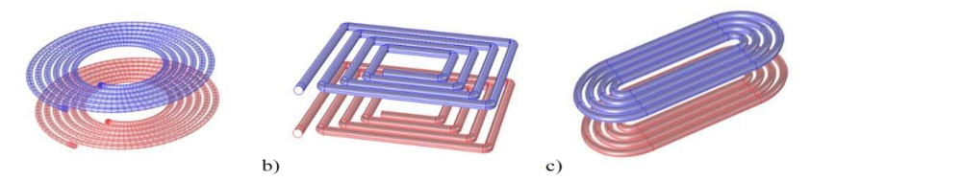
FigureⅡ.1 The inductive magnetic coupling
This technique is widely used for wireless charging of the internal battery of, consumer devices such as electric toothbrushes or wireless mice [4].
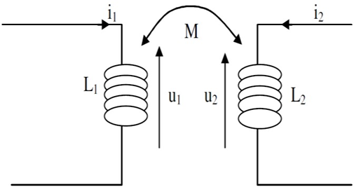
FigureⅡ.2 the inductive magnetic coupling
$$U_{1}=L_{1}\frac{{di}_{1}}{dt}+M\frac{{di}_{2}}{dt}$$ | II.1
$$U_{2}=L_{2}\frac{{di}_{2}}{dt}+M\frac{{di}_{1}}{dt}$$ | II.2
Where L1 is the transmitting coil and L2 is the receiving coil and M is the mutual inductance of the system. U1 and U2 are the voltage and I1, I2 are the current contrôle

I.2.1.2 Resonant magnetic coupling
The magnetic resonance coupling is between two structures, the transmission structure is composed of a cycle and a coil, when the signal from the generator reaches the coil, the oscillating magnetic field excites the transmission coil which behaves like a RLC resonant circuit.
When the receiver continues to behave similarly, the source is replaced by the load to be operated [6]. Circular windings allow energy to be transmitted in the near field.
Resonant coupling is more efficient than non-resonant inductive coupling, and this improvement is due to the use of a robust resonant body coupling system, which allows transmission amplification [5].
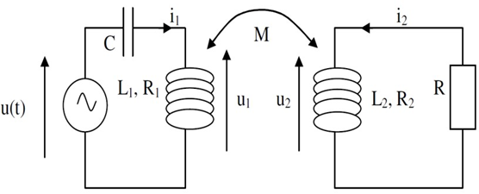
Figure Ⅱ.3 Wireless power transmission by resonant coupling
Writing the lattice laws in complex notation, defining relations with complex quantities:
$$U=R_{1}.i_{1}+jL_{1}ωi_{1}+jMωi_{2}+\frac{1}{jcω}i_{1}$$ | II.3
$$i_{2}=\frac{_jMω}{R_{2}+R+jL_{2}ω}i_{1}$$ | II.4

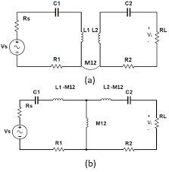
Figure Ⅱ.4 depicts the equivalent T model for two IPT coils
In order to improve the transmission efficiency performance, a four-coil IPT system is proposed through the use of additional transceiver files.
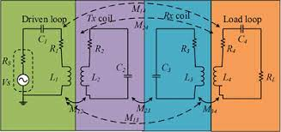
Figure Ⅱ.5 depicts an equivalent T model for four-coil IPT system
Where C1, C2, C3, C4, R1, R2, R3 and R4 are respectively, the parasitic capacitances and the parasitic resistances.
A capacitor is used to store opposite electrical charges on its armatures, it is used in particular to stabilize a power supply because it discharges during voltage drops and charges during voltage peaks. It is used to process periodic signals, for filtering for example. It is used to separate an alternating current from a direct current because it blocks the latter, and of course to store energy.
Resonance capacitors are needed to cancel the reactive parts at given frequency. The compensation is here associated with a given inductance in the electrical model.
Inductance compensation consists of connecting a capacitor (in series (S) or in parallel (P) depending on the topology) and choosing its value so as to cancel the equivalent impedance at a given frequency [2].
Technology | Performance
Technology | Efficiency | EMI | Frequency
Inductive Power Transfer (IPT) | Medium | Medium | 10-50 kHz
Capacitive Power Transfer (CPT) | Low | Medium | 100-500 kHz
The main differences between the two induction methods (IPT and CPT) are shown in Table II.1.
Table II.1 Comparison between IPT and CPT system

II.2.2 Far-field WPT
which is also called electromagnetic radiation WPT. It includes microwave power transfer (MPT), laser power transfer (LPT), and solar power satellites (SPS) [2].

II.2.2.1 Radio wave and microwave
Microwave transmission refers to the technology of energy transmission by the use of electromagnetic waves whose wavelengths are conveniently measured in small numbers of a centimeter; they are called microwave ovens.
Wireless power transmission using microwaves needs a source of electromagnetic radiation, and a microwave receiver with a DC rectifier to convert microwave energy into DC electrical energy.
The transmitting and receiving units must be in the line of sight, and the electrical energy is first converted into microwave energy in the transmitter which travels over a distance to the receiver which contains the retina which converts these microwaves into electrical energy.
AC cannot be directly converted into microwave in the transmitter, it must be converted into DC with the oscillator in the receiver, and the DC output of the retina is converted into AC for use.

II.2.2.2 Laser
A laser is a device that emits light through a photoamplification process based on the stimulated emission of electromagnetic radiation. Lasers differ from other light sources because they emit coherent light. Spatial coherence allows the laser to focus on a narrow point.
The radiation production mechanism in lasers is based on stimulated emission, where energy is extracted from a transmission in an atom or molecule. Energy can be transferred by converting electricity into a laser beam that is then directed at a photovoltaic cell, this mechanism is commonly known as “power transmission” because the energy is broadcast into a receiver that can convert it into electrical energy .
There are many advantages in this system: The beam's narrow cross-sectional area allows for transmission over large distances; Compact size; There is no radio frequency interference in current wireless communications.
They are also not without flaws: Laser radiation is dangerous, conversion between electricity and light is inefficient, atmospheric absorption, absorption and scattering by clouds, fog, rain, etc. requires direct line of sight with the target [3].

II.2.3 Differences between NFWPT and FFWPT
The main differences between the two types of panels NFWPT and FFWPT are shown in Table II.2.
Table II.2 Main differences between FFWPTT and NFWPTT

WPT | Far Field | Near Field
Range | Long | Short-Mid
Phenomenon | Coupled mode theory | Induction theory
Frequency | Mega Hertz | Kilo Hertz
Efficiency | Low | High

II.2.4 Radiative transfer
Energy can also be transmitted over a distance through a high frequency radiative field in far field or radiative technologies, beams of high-frequency electromagnetic radiation transmit energy.
This method uses high frequency electromagnetic waves usually above 1 GHz, and the energy is transmitted in far fields
These technologies can transmit energy over longer distances but must be aimed at the receiver, and a receiver tracking mechanism must be required to adjust the direction of the radiation beam. Ultimately, the interference of the electric field with the human body poses a threat to human health, and therefore, safety standards are developed to limit the exposure of the person to electromagnetic fields.
In addition, this type of transmission is still well suited for high power transmission to the desert, such as solar transmission [2].
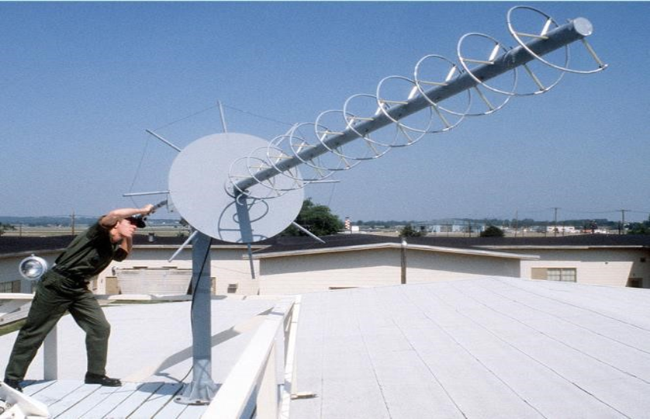
Figure Ⅱ.6 Wireless power transfer through a high directivity antenna

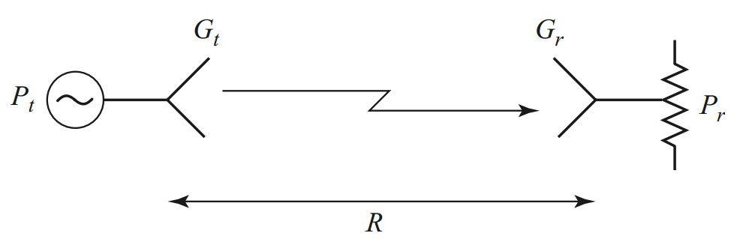
Figure Ⅱ.7 Basic radio system, such as microwaves or lasers.

II.3 Fields application of WPT
- WPT technologies provide capabilities to harness power
- Air without the limitations of the traditional wire, and dynamic contactless charging technology
- We come into our daily lives as electric vehicles, biomedical implants, and portable electronics.
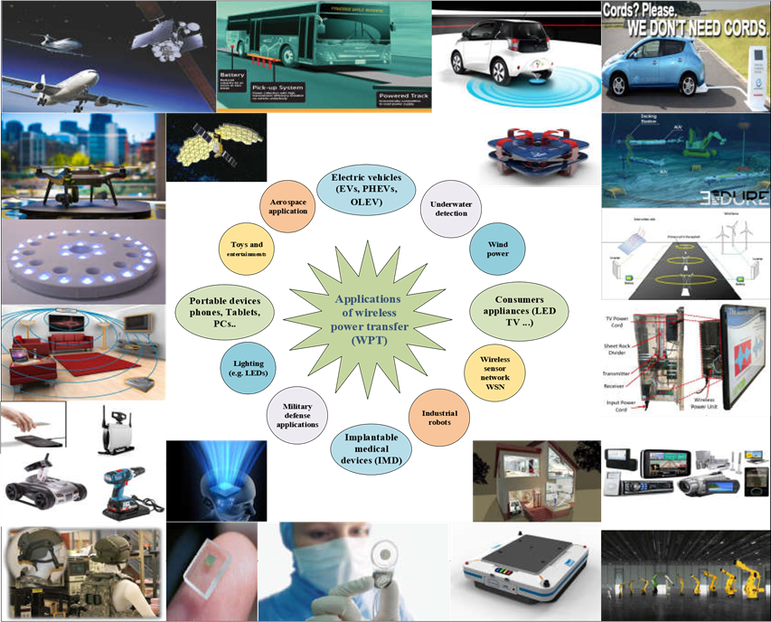
Figure Ⅱ.8 WPT applications.
It has become an important part in some basic areas, the most important of which are:
- Electric vehicles it is a promising technology.
- Implantable medical devices (IMDs) it provides a safe and convenient way to deliver power wirelessly without any pain to the patient.
- The field of consumer electronic applications, WPT is used in LED TVs, charging mobile devices such as mobile phones, tablets and other smart building devices.
- WPT systems are used in LED lights, underwater scouts, and the military
Defense systems, space applications, etc [5].

II.4 Benefits and drawbacks of WPT

I.4.1 Benefits
Wireless power transfer technology is considered one of the greatest technologies of the era Among its benefits are the following:
- Get rid of wires and cables
- Easily charge the battery.
- Reducing the cost associated with manufacturing
- Ease of use

I.4.2 Drawbacks
Like other technologies, this technology also has drawbacks :
- Low amount of power and longer charging time.
- Wireless technology requires a power cord.
- It still requires the use of a wire to connect the charging base to the mains
- Complex technology.
- In the case of radioactive transfer at high frequencies, the system may pose health risks.
- Expensive technology.
- Hazardous to the environment due to the number of components required to make it work.
- Has a certain number of technological or environmental constraints (allowable power level; electromagnetic compatibility) [2].

II.5 Conclusion
First, we start by introducing the state of the art in the field of wireless power transfer and after that we detail the technologies of wireless power transmission; we touched the different areas of wireless power transfer applications.
Wireless transfer of electrical energy proves to be an innovative and effective means of transfer, by converting electrical energy into electromagnetic waves, enabling us to transmit energy without the use of wires.
Finally, with the development of resonance coupling technology, wireless transmission can take place over long and long distances, and this will be the perfect solution to overcome the current energy problems and environmental crisis.

Chapter III

Theoretical Formulation of the problem of WPT using Resonant Magnetic field Coupling

III.1 Introduction
In this chapter, we will present the Theoretical Formulation of the problem of WPT using Resonant Magnetic field coupling.
First, we start introducing and explaining the principal of Two-Coil Resonant WPT System by using three models a simple, horizontally and vertically
We have analyzed the resonance peaks with MATLEB (2016).
According to the input impedance (Z_11) curves, the capacitive curve is in the low frequency region across the series.

III.2 Two-Coil Resonant WPT System
WPT, by its definition, is the transmission of electrical energy from a power source to an electrical load without intentionally placed interconnecting wires or conductors.
A power source produces a current through the transmitting coil, and a magnetic field is generated perpendicular to the direction of the current in accordance with Fleming's right-hand rule. As the magnetic field passes through the receiving coil, an electromotive force is generated, which causes a current to be generated in the receiving coil and induces a voltage on the load. To minimize the reactance and maximize the power transferred between the magnetically coupled coils, resonant magnetic field coupling is commonly employed using tuning capacitors.
The application of this principle enables power to be transferred wirelessly such that it can be used for the charging of batteries or other suitable loads for a wide range of electronic devices.
Such a two-coil system consists of transmitting and receiving coils, which are mutually coupled through a resonant magnetic field by tuning capacitors connected in series. To achieve tight magnetic coupling, the two coils are located within a short distance of each other (within 2 cm in the case of a common wireless smart mobile phone charger).
The printed circuit boards (PCBs) of a smart mobile phone and its charger are placed near both coils. Many different chips, such as a mobile processor, a power control unit, memory chips, a transceiver and receiver for communication, and various sensors, are embedded in the PCB of a smart mobile phone.
When a power source produces a current, a magnetic coupling is formed between the transmitting coil and the receiving coil. is the magnetic coupling coefficient. The tuning capacitors and are connected in series to the transmitting and receiving coils, respectively, to produce magnetic field resonance at the same frequency. Includes the internal resistance of the source and the resistance of the transmitting coil.
The equation for input impedance can be derived based on the simplified equivalent circuit model [1].

III.3 Resonant magnetic field coupling
A power source produces a current through the transmitting coil, and a magnetic field is generated perpendicular to the direction of the current in accordance with Fleming's right-hand rule. As the magnetic [1].
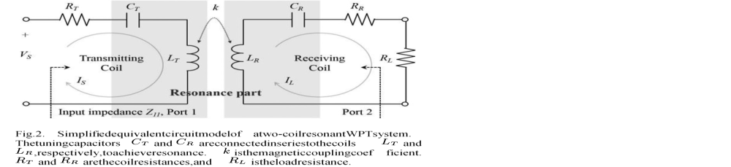

Figure Ⅲ.1 Resonant part
$$\left\{\begin{aligned}R_{T}:resistance for transmission coil \\ C_{T}:capacitor for the transmission coil \\ L_{T}:Inductorfor the transmission coil \\ I_{s}: transmission current \\ V_{s}:transmission voltage\end{aligned}\right. k:is magnetic coupling coeficcient \left\{\begin{aligned}R_{R}:resistance for Receiving coil \\ C_{R}:capacitor for the Receiving coil \\ L_{R}:Inductorfor the Receiving coil \\ I_{L}: Receiving current \\ R_{L}:the load resistance\end{aligned}\right.$$
Load resistance defines the loading parameters of a circuit. If you examine different circuits with a load resistor, changing their values will help you find the load capacity of that circuit for that load resistance. Load resistors are used for impedance matching, maximum power transfer, to improve output stability and to ensure a minimum of current flow. in switching power supplies, they are essential for the proper operation of the psu.
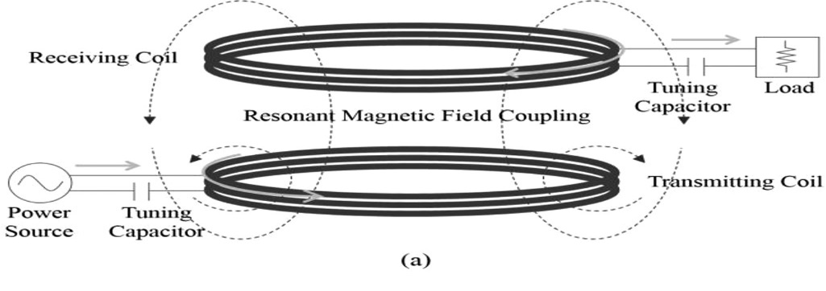

Figure Ⅲ.2 Resonant magnetic field coupling
The equation for input impedance can be derived based on the simplified equivalent circuit model.

II.3.1 Input Impedance
Figure III.1 show the Resonant part between Primary and Secondary coil.
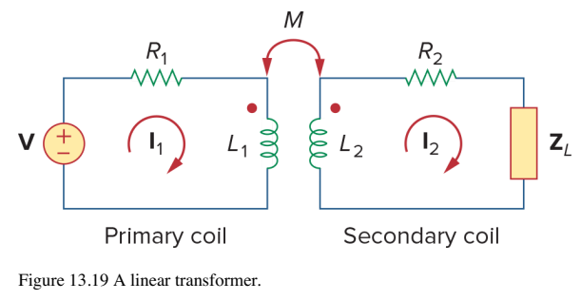

Figure Ⅲ.3 Resonant part between Primary and Secondary coil
We would like to obtain the input Impedance $Z_{in}$ as seen from the source, because $Z_{in}$governs the behavior of the primary circuit . Applying KVL to the two meshes gives
$$\left\{\begin{aligned}V=\left(R_{1}+jωL_{1}\right)I_{1}-jωMI_{2} \\ 0=-jω{ML}_{1}+\left(R_{2}+jωL_{2}+Z_{L}\right)I_{2} \end{aligned}\right.$$ | III.1
We express $I_{2}$ in terms of $I_{1}$ and we get the input Impedance as
$$Z_{in}=\frac{V}{I_{1}}=R_{1}+jωL_{1}+\frac{ω^{2}M^{2}}{R_{2}+jωL_{2}+Z_{L}}$$ | III.2
Notice that the input impedance comprises two terms .The first term $\left(R_{1}+jωL_{1}\right)$,is the primary impedance .The second term is due to the coupling between the primary and secondary windings .It is as though this impedance is reflected to the primary .Thus ,it is known as the reflected $Z_{R}$ and some authors call this coupled impedance .
$$Z_{R}=\frac{ω^{2}M^{2}}{R_{2}+jωL_{2}+Z_{L}}$$ | III.3
It should be noted that the result in (III.2) or (III.3) is not affected by the location of the dots on the transformer, because the same result is, produces when M is replaced by –M [7].
We shall apply the above results for the following circuit :

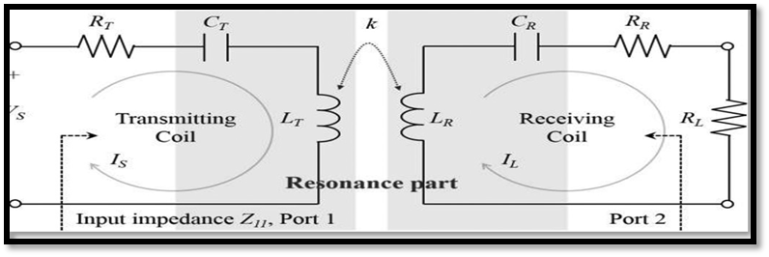

$$\left\{\begin{aligned}R_{T}:resistance for transmission coil \\ C_{T}:capacitor for the transmission coil \\ L_{T}:Inductorfor the transmission coil \\ I_{s}: transmission current \\ V_{s}:transmission voltage\end{aligned}\right. k:is magnetic coupling coeficcient \left\{\begin{aligned}R_{R}:resistance for Receiving coil \\ C_{R}:capacitor for the Receiving coil \\ L_{R}:Inductorfor the Receiving coil \\ I_{L}: Receiving current \\ R_{L}:the load resistance\end{aligned}\right.$$
We write :
$$Z_{in}=Z_{11}$$
$$V=V_{S}$$
$$\begin{matrix}I_{1}=I_{P}; & I_{2}=I_{S}\end{matrix}$$
$$\begin{matrix}R_{1}=R_{T}+\frac{1}{jωC_{T}}; & L_{1}=L_{T}\end{matrix}$$
$$M=k\sqrt{L_{1}L_{2}}$$
$$\begin{matrix}L_{2}=L_{R}; & R_{2}=R_{R}+\frac{1}{jωC_{R}}; & Z_{L}=R_{L}\end{matrix}$$
$$L_{T}C_{T}=L_{R}C_{R}=LC$$
Hence
$$Z_{in}=R_{1}+jωL_{1}+\frac{ω^{2}M^{2}}{R_{2}+jωL_{2}+Z_{L}}=Z_{11}$$
$$=R_{T}+\frac{1}{jωC_{T}}+jωL_{T}+\frac{ω^{2}{\left(k\sqrt{L_{T}L_{R}}\right)}^{2}}{R_{T}+\frac{1}{jωC_{T}}+jωL_{R}+R_{L}}$$
$$Z_{in}=R_{1}+jωL_{1}+\frac{ω^{2}M^{2}}{R_{2}+jωL_{2}+Z_{L}}$$  $$=Z_{11}$$ | III.4
$$Z_{in}=R_{T}+\frac{1}{jωC_{T}}+jωL_{T}+\frac{ω^{2}{\left(k\sqrt{L_{T}L_{R}}\right)}^{2}}{R_{T}+\frac{1}{jωC_{T}}+jωL_{R}+R_{L}}$$ | III.5
$$\left[\begin{matrix}V_{S} \\ 0\end{matrix}\right]\left[\begin{matrix}R_{T}+j({ωL}_{T}-\frac{1}{{ωC}_{T}}) & -J{ωM}_{k} \\ -J{ωM}_{k} & \left(R_{R}+R_{l}\right)+j\left({ωL}_{R}-\frac{1}{{ωC}_{R}}\right)\end{matrix}\right] \left\lceil \begin{matrix}Is \\ I_{L}\end{matrix}\right\rceil$$ | III.6
Using (III.6) and considering the cross coupling the correct in each resonator can be expressed by
$$\left\{\begin{aligned}I_{S}=\frac{V_{S}}{ \frac{[R_{T}+j({ωL}_{T}-\frac{1}{{ωC}_{T}})][R_{R}+R_{l}+j\left({ωL}_{R}-\frac{1}{{ωC}_{R}}\right) ]+ω^{2}M_{k}}{\begin{aligned}\begin{aligned}\begin{aligned}\begin{aligned}R_{R}+R_{l}+j\left({ωL}_{R}-\frac{1}{{ωC}_{R}}\right)\end{aligned}\end{aligned}\end{aligned}\end{aligned}}} \\ \begin{aligned}\begin{aligned}I_{L}\begin{aligned} =\frac{-J{ωM}_{k} Is}{R_{R}+R_{l}+j\left({ωL}_{R}-\frac{1}{{ωC}_{R}}\right)}\end{aligned}\end{aligned}\end{aligned}\end{aligned}\right.$$ | III.7
$Z_{in}=\frac{V_{S}}{I_{S}} =Z_{11}$
$Z_{11}=\frac{\left[R_{T}+j\left({ωL}_{T}-\frac{1}{{ωC}_{T}}\right)\right]\left[R_{R}+R_{l}+j\left({ωL}_{R}-\frac{1}{{ωC}_{R}}\right)\right]+ω^{2}M_{k}}{R_{R}+R_{l}+j\left({ωL}_{R}-\frac{1}{{ωC}_{R}}\right)}$
$$L_{T}C_{T=}L_{R}C_{R}=LC$$
$$M_{k} =K\sqrt{L_{T}L_{R}}$$
$$Z_{11}=\frac{j\left[-j{ωC}_{T}R_{T}+L_{T}C_{T}ω^{2}-1\right]j \left[-jω\left(R_{R}+R_{l}\right)C_{R}+{ω^{2}L}_{R}C_{R}-1\right]+ω^{4}k^{2}L_{R}L_{T}C_{T}C_{R}}{\begin{aligned}j{ωC}_{T}[-j\left(R_{R}+R_{l}\right)+\end{aligned}ω^{2}L_{R}C_{R}-1]}$$
$$=\frac{{[ωC}_{T}R_{T}+j(ω^{2}L_{T}C_{T}-1)][{ωC}_{R}\left(R_{R}+R_{l}\right)+j(ω^{2}L_{R}C_{R}-1)]+ω^{4}k^{2}L_{R}L_{T}C_{T}C_{R}}{{ωC}_{T}\left[{ωC}_{R}\left(R_{R}+R_{l}\right)+j\left(ω^{2}L_{R}C_{R}-1\right)\right]}$$
$$=\frac{\left[j{ωC}_{T}R_{T}+1-L_{T}C_{T}ω^{2}\right]\left[jω\left(R_{R}+R_{l}\right)C_{R}+1-ω^{2}L_{R}C_{R}\right]-ω^{4}k^{2}L_{R}L_{T}C_{R}C_{T}}{j{ωC}_{T}\left[j{ωC}_{R}\left(R_{R}+R_{l}\right)+1-ω^{2}L_{R}C_{R}\right]}$$

$$Z_{11}=\frac{\left[jωC_{T}R_{T}+1-ω^{2}LC\right]\left[jω\left(R_{R}+R_{l}\right)C_{R}+1-ω^{2}LC\right]-ω^{4}k^{2}L^{2}C^{2}}{jωC_{T}\left[jωC_{R}\left(R_{R}+R_{l}\right)+1-ω^{2}LC\right]}$$ | III.8

Method 2 :
$$Z_{11}=R_{T}+j\left(L_{T}ω-\frac{1}{C_{T}ω}\right)+\frac{k^{2}L_{T}L_{R}ω^{2}}{R_{R}+R_{L}+j\left(L_{R}ω-\frac{1}{C_{R}ω}\right)}$$  $$=\frac{\left[R_{T}+j\left(L_{T}ω-\frac{1}{C_{T}ω}\right)\right]\left[R_{R}+R_{L}+j\left(L_{R}ω-\frac{1}{C_{R}ω}\right)\right]+k^{2}L_{T}L_{R}ω^{2}}{R_{R}+R_{L}+j\left(L_{R}ω-\frac{1}{C_{R}ω}\right)}$$ | III.9
$$=\frac{C_{T}ω\left[R_{T}+j\left(L_{T}ω-\frac{1}{C_{T}ω}\right)\right]C_{R}ω\left[R_{R}+R_{L}+j\left(L_{R}ω-\frac{1}{C_{R}ω}\right)\right]+\left(C_{T}ω\right)\left(C_{R}ω\right)k^{2}L_{T}L_{R}ω^{2}}{\left(C_{T}ω\right)\left(C_{R}ω\right)\left[R_{R}+R_{l}+j\left(L_{R}ω-\frac{1}{C_{R}ω}\right)\right]}=\frac{\left[R_{T}C_{T}ω+j\left(L_{T}C_{T}ω^{2}-1\right)\right]\left[\left(R_{R}+R_{L}\right)C_{R}ω+j\left(L_{R}C_{R}ω^{2}-1\right)\right]+k^{2}L_{T}C_{T}L_{R}C_{R}ω^{4}}{ωC_{T}\left[\left(R_{R}+R_{L}\right)C_{R}ω+j\left(L_{R}C_{R}ω^{2}-1\right)\right]}=\frac{j\left[-jωR_{T}C_{T}+L_{T}C_{T}ω^{2}-1\right]j\left[-jω\left(R_{R}+R_{L}\right)C_{R}+L_{R}C_{R}ω^{2}-1\right]+k^{2}L_{T}C_{T}L_{R}C_{R}ω^{4}}{jωC_{T}\left[-j\left(R_{R}+R_{L}\right)C_{R}ω+L_{R}C_{R}ω^{2}-1\right]}=\frac{-\left[-jωR_{T}C_{T}+L_{T}C_{T}ω^{2}-1\right]\left[-jω\left(R_{R}+R_{L}\right)C_{R}+L_{R}C_{R}ω^{2}-1\right]+k^{2}L_{T}C_{T}L_{R}C_{R}ω^{4}}{-jωC_{T}\left[jωC_{R}\left(R_{R}+R_{L}\right)+1-L_{R}C_{R}ω^{2}\right]}=\frac{-\left[jωR_{T}C_{T}+1-L_{T}C_{T}ω^{2}\right]\left[jω\left(R_{R}+R_{L}\right)C_{R}+1-L_{R}C_{R}ω^{2}\right]+k^{2}L_{T}C_{T}L_{R}C_{R}ω^{4}}{-jωC_{T}\left[jωC_{R}\left(R_{R}+R_{L}\right)+1-L_{R}C_{R}ω^{2}\right]}=\frac{\left[jωR_{T}C_{T}+1-ω^{2}L_{T}C_{T}\right]\left[jω\left(R_{R}+R_{L}\right)C_{R}+1-ω^{2}L_{R}C_{R}\right]-k^{2}L_{T}C_{T}L_{R}C_{R}ω^{4}}{jωC_{T}\left[jωC_{R}\left(R_{R}+R_{L}\right)+1-L_{R}C_{R}ω^{2}\right]}=\frac{\left[jωR_{T}C_{T}+1-ω^{2}LC\right]\left[jωC_{R}\left(R_{R}+R_{L}\right)+1-ω^{2}LC\right]-ω^{4}k^{2}L^{2}C^{2}}{jωC_{T}\left[jωC_{R}\left(R_{R}+R_{L}\right)+1-LCω^{2}\right]}$$
Hence
$$Z_{11}=\frac{\left[jωC_{T}R_{T}+1-ω^{2}LC\right]\left[jω\left(R_{R}+R_{l}\right)C_{R}+1-ω^{2}LC\right]-ω^{4}k^{2}L^{2}C^{2}}{jωC_{T}\left[jωC_{R}\left(R_{R}+R_{l}\right)+1-ω^{2}LC\right]}$$ | III.10

III.3.2 Simulation results
We have applied this demand, and the result is as follows equation to the « the program on MATLAB 2016 »
The program is:
clear;
clc;
format long g;
RT=2.1;
CT=211.1e-12;
LT=2.61e-6;
LR=2.61e-6;
CR=211.1e-12;
RR=2.1;
RL=1;
k=0.17;
CTRT=CT*RT;
LC=LT*CT;
CR4L=CR*(RR+RL);
freq=1e6*linspace(0.3,20,1000);
omega=2*pi*freq;
omega2=omega.^2;
omega2LC=omega2*LC;
jomega=j*omega;
P1=jomega*CTRT+1-omega2LC;
P2=jomega*CR4L+1-omega2LC;
NUM=P1.*P2-(k*omega2LC).^2;
DEN=(jomega*CT).*P2;
Z_11=NUM./DEN;
loglog(1.e-6*freq,abs(Z_11));grid;figure(gcf);

The result is

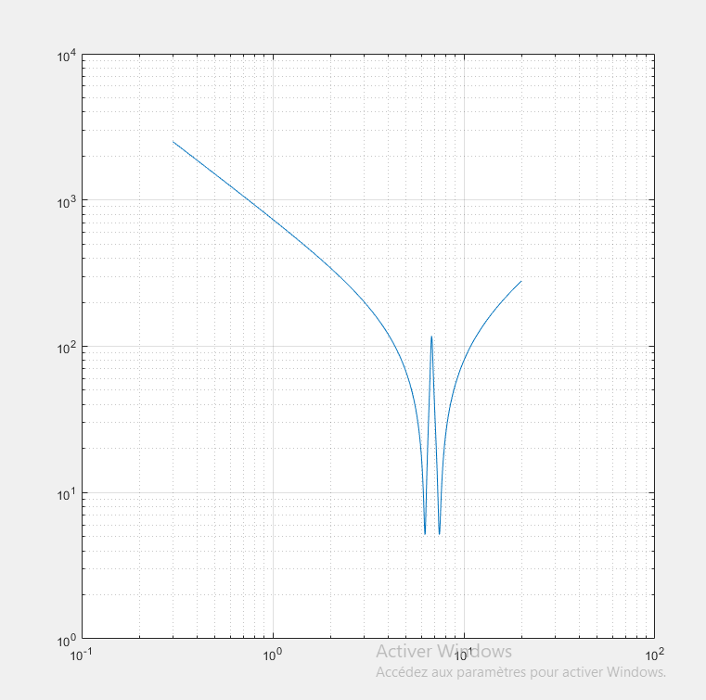
Z11(dB)
Frequency (MHZ)
$$L_{S}$$

$$C_{R}$$
f1
f3
f2
$$L_{R}$$
$$C_{T}$$

Figure Ⅲ.4 Z11 of resonant magnetic field coupling

Comment

The resonance peaks show a good agreement with the MATLEB Application (2016).
Through the results extracted from it, we note that the energy is converted wirelessly by converting electrical energy (Vs source voltage) into electromagnetic energy that travels through the air, due to the short distance between the transmitting coil and the receiving coil, so it decreases to f2 and then returns to decrease at f1.
Note, the result obtained by IEEE TRANSACTIONS ON MICROWAVE THEORY AND TECHNIQUES is:
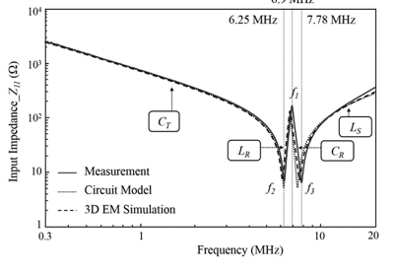
Input impedance curves obtained from the circuit model (dotted line) and through 3-D EM simulation (dashed line) and measurement (solid line) of two-coil system. The resonance peaks predicted by the circuit model exhibit good agreement with the 3-D EM simulation and measurement results. Of the coils. According to the input impedance curves, the capacitive curve in the low-frequency region up through the series [1].

III.4 Resonance Peak Changes in Multi-Coil Resonant WPT Systems

III.4.1 Multi-coil configuration vertical
In the case of a vertically coupled multi-coil system, a repeating coil Simplified equivalent circuit models of vertically and horizontally coupled multi-coil resonant WPT systems.
The model for a vertically coupled multi-coil system, shown in Fig below, consists of the transmitting coil, receiving coil, and repeating coil. The magnetic coupling coefficients and form between the transmitting, receiving, and repeating coils [1].
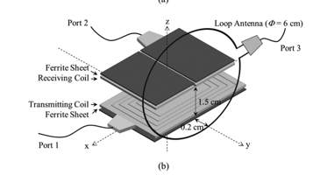
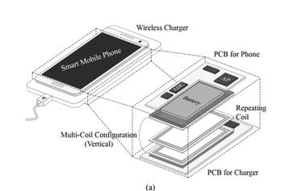

Figure Ⅲ.5 Multi-coil configuration Vertical inside smartphone
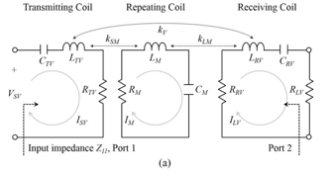

FigureⅢ. 6 related electrical circuits of Multi-coil configuration vertical
We write $Z_{in}=Z_{11}$ :
$\left[\begin{matrix}V_{sv} \\ 0 \\ 0\end{matrix}\right]$=$\left[\begin{matrix}R_{TV}+j\left({ωL}_{TV}-\frac{1}{{ωC}_{TV}}\right) & -j{ωM}_{SM} & -j{ωM}_{v} \\ -j{ωM}_{SM} & R_{M}+j\left({ωl}_{M}-\frac{1}{{ωC}_{M}}\right) & -j{ωMl}_{M} \\ -j{ωM}_{v} & -j{ωMl}_{M} & \left(R_{RV}+R_{LV}\right)+j\left(ωL_{RV}-\frac{1}{ωC_{RV}}\right)\end{matrix}\right] \left\lceil \begin{matrix}I_{SV} \\ I_{M} \\ I_{LV}\end{matrix}\right\rceil$ | III.11

Using (II.11) and considering the cross coupling the current in each resonator can be expressed by:

$$\left\{\begin{aligned}I_{SV}=\frac{V_{SV}}{R_{TV}+j\left({ωL}_{TV}-\frac{1}{{ωC}_{TV}}\right)+\frac{ω^{2}{M_{SM}}^{2}\left[R_{RV}+R_{LV}+j\left(ωL_{RV}-\frac{1}{ωC_{RV}}\right)\right]+ω^{2}{M_{v}}^{2}{[R}_{M}+j\left({ωl}_{M}-\frac{1}{{ωC}_{M}}\right)]+2jω^{3}M_{SM}{Ml}_{M} M_{v}}{\begin{aligned}ω^{2}{{Ml}_{M}}^{2}+\left[R_{M}+j\left({ωl}_{M}-\frac{1}{{ωC}_{M}}\right)\right] \end{aligned}\left[R_{RV}+R_{LV}+j\left(ωL_{RV}-\frac{1}{ωC_{RV}}\right)\right]}} \\ I_{M}=\frac{-{jωM}_{SM}\left[\left(R_{RV}+R_{LV}\right)+j\left(ωL_{RV}-\frac{1}{ωC_{RV}}\right)\right]+ω^{2}M_{v}{Ml}_{M}}{\left[R_{M}+j\left({ωl}_{M}-\frac{1}{{ωC}_{M}}\right)\right]\left[R_{RV}+R_{LV}+j\left(ωL_{RV}-\frac{1}{ωC_{RV}}\right)\right]+ω^{2}{Ml}_{M}}{ I}_{SV} \\ I_{LV}=\frac{-ω^{2}M_{SM}{Ml}_{M}+j{ωM}_{v}\left[R_{M}+j\left({ωl}_{M}-\frac{1}{{ωC}_{M}}\right)\right]}{\left[R_{M}+j\left({ωl}_{M}-\frac{1}{{ωC}_{M}}\right)\right]\left[R_{RV}+R_{LV}+j\left(ωL_{RV}-\frac{1}{ωC_{RV}}\right)\right]+ω^{2}{Ml}_{M}}{ I}_{SV}\end{aligned}\right.$$ | III.12
And $Z_{in}=\frac{V_{SV}}{I_{SV}} =Z_{11}$

$${Z_{11}=R}_{TV}+j\left({ωL}_{TV}-\frac{1}{{ωC}_{TV}}\right)+\frac{\begin{aligned}ω^{2}{M_{SM}}^{2}\left[\left(R_{RV}+R_{LV}\right)+j\left(ωL_{RV}-\frac{1}{ωC_{RV}}\right)\right]+ω^{2}{M_{v}}^{2}\left[R_{M}+j\left({ωl}_{M}-\frac{1}{{ωC}_{M}}\right)\right] \\ +2jω^{3}M_{SM}{Ml}_{M} M_{v}\end{aligned}}{\begin{aligned}ω^{2}{{Ml}_{M}}^{2}+[R_{M}+j\left({ωl}_{M}-\frac{1}{{ωC}_{M}}\right)][\left(R_{RV}+R_{LV}\right)+j\left(ωL_{RV}-\frac{1}{ωC_{RV}}\right) \\ =\frac{\begin{aligned}ω^{2}{{Ml}_{M}}^{2}\left[R_{TV}+j\left({ωL}_{TV}-\frac{1}{{ωC}_{TV}}\right)\right]+ \\ \left[R_{TV}+j\left({ωL}_{TV}-\frac{1}{{ωC}_{TV}}\right)\right]\left[R_{M}+j\left({ωl}_{M}-\frac{1}{{ωC}_{M}}\right)\left[\left(R_{RV}+R_{LV}\right)+j\left(ωL_{RV}-\frac{1}{ωC_{RV}}\right)\right]\right]+ω^{2}{M_{SM}}^{2}\left[\left(R_{RV}+R_{LV}\right)+j\left(ωL_{RV}-\frac{1}{ωC_{RV}}\right)+j\left(ωL_{RV}-\frac{1}{ωC_{RV}}\right)\right] \\ +ω^{2}{M_{v}}^{2}{[R}_{M}+j\left({ωl}_{M}-\frac{1}{{ωC}_{M}}\right)]+2jω^{3}M_{SM}{Ml}_{M} M_{v}\end{aligned}}{ω^{2}{{Ml}_{M}}^{2}+\left[R_{M}+j\left({ωl}_{M}-\frac{1}{{ωC}_{M}}\right)\right]\left[\left(R_{RV}+R_{LV}\right)+j\left(ωL_{RV}-\frac{1}{ωC_{RV}}\right)\right]}\end{aligned}}$$ | III.13

where
$L_{TV}C_{TV}=L_{M}C_{M}$=$L_{RV}C_{RV}=LC$, ${ML}_{M}=$K$L_{M}\sqrt{L_{M}L_{RV}}$, $M_{SM} = K_{SM}\sqrt{L_{TV}l_{M}}$, $M_{V}=K_{V}\sqrt{L_{TV}L_{RV}}$
Hence
$$Z_{11}Vartical =\frac{\begin{aligned}2ω^{6}K_{SM}KL_{M}K_{V}L^{3}C^{3}-{ω^{4}L}^{2}C^{2}\left[\begin{aligned}{K_{V}}^{2}\left(jωR_{M}C_{M}+\left(1-ω^{2}LC\right)\right)+{KL_{M}}^{2}\left[({jωC}_{TV}R_{TV}+\left(1-ω^{2}LC\right)\right] \\ +{K_{SM}}^{2}\left[jωC_{RV}\left(R_{RV}+R_{LV}\right)+\left(1-ω^{2}LC\right)\right]\end{aligned}\right] \\ +(j{ωC}_{TV}R_{TV}+1-ω^{2}LC)(jωR_{M}C_{M}+1-ω^{2}LC)(jωC_{RV}\left(R_{RV}+R_{LV}\right)+1-ω^{2}LC)\end{aligned}}{j{ωC}_{TV}\left[(jωR_{M}C_{M}+j\left(1-ω^{2}LC\right)\right]\left[jωC_{RV}\left(R_{RV}+R_{LV}\right)+\left(1-ω^{2}LC\right)\right]{-ω}^{4}{KL_{M}}^{2}L^{2}C^{2}]}$$ | III.14

III.4.2 Simulation results
We have applied this equation to the demand, and the result is as follows “the program on MATLEB 2016”
The program is :
clear;
clc;
format long g;
MAT=[2.61e-6 2.55e-6 2.62e-6
211.1e-12 216.1e-12 210.3e-12
2.1 3.1 2.5
1 1 1
1.89e-6 2.19e-6 2.25e-6
291.6e-12 251.6e-12 244.9e-12
2.1 2.4 1.4
4.18e-6 4.61e-6 4.95e-6
131.8e-12 119.5e-12 111.3e-12
3.4 6.2 5.4
-0.17 -0.2 -0.21
-0.45 -0.49 -0.49
-0.29 -0.31 -0.29
-0.13 -0.14 -0.15
];
freq=1e6*linspace(0.3,20,1000).';
omega=2*pi*freq;
jomega=j*omega;
omega2=omega.^2;
omega4=omega2.*omega2;
omega6=omega2.*omega4;
Z11_Vertical=[];
for i=1:3
LT=MAT(1,i);
LR=LT;
LTV=LT;
LRV=LT;
LRH=LT;
CT=MAT(2,i);
CR=CT;
CTV=CT;
CRV=CT;
CRH=CT;
RT=MAT(3,i);
RR=RT;
RTV=RT;
RRV=RT;
RRH=RT;
RL=MAT(4,i);
RLV=RL;
RLH=RL;
LM=MAT(5,i);
CM=MAT(6,i);
RM=MAT(7,i);
LTH=MAT(8,i);
CTH=MAT(9,i);
RTH=MAT(10,i);
k=MAT(11,i);kV=k;
kSM=MAT(12,i);
kLM=MAT(13,i);
kH=MAT(14,i);
LC=LTV*CTV;
CMRM=CM*RM;
CTVRTV=CTV*RTV;
LC2=LC^2;
LC3=LC^3;
omega2LC=omega2*LC;
unmomega2LC=1-omega2LC;
term0=2*omega6*kSM*kLM*kV*LC3;
coef1=omega4*LC2;
parenthesis1=jomega*CMRM+unmomega2LC;
parenthesis2=jomega*CTVRTV+unmomega2LC;
parenthesis3=jomega*CRV*(RRV+RLV)+unmomega2LC;
parenthesis_big=kV^2*parenthesis1+kLM^2*parenthesis2+kSM^2*parenthesis3;
NUMER=term0-coef1.*parenthesis_big+parenthesis1.*parenthesis2.*parenthesis3;
DENOM=jomega*CTV.*(parenthesis1.*parenthesis2-omega4*kLM^2*LC2);
Z11_Vertical=[Z11_Vertical NUMER./DENOM];
end
loglog(1.e-6*freq,abs(Z11_Vertical));grid;figure(gcf);
xlabel('Frequency (MHz)');
ylabel('Z_{11} (dB)')

RL=MAT(4,i);
RLV=RL;
RLH=RL;
LM=MAT(5,i);
CM=MAT(6,i);
RM=MAT(7,i);
LTH=MAT(8,i);
CTH=MAT(9,i);
RTH=MAT(10,i);
k=MAT(11,i);kV=k;
kSM=MAT(12,i);
kLM=MAT(13,i);
kH=MAT(14,i);
LC=LTV*CTV;
CMRM=CM*RM;
CTVRTV=CTV*RTV;
LC2=LC^2;
LC3=LC^3;
omega2LC=omega2*LC;
unmomega2LC=1-omega2LC;
term0=2*omega6*kSM*kLM*kV*LC3;
coef1=omega4*LC2;
parenthesis1=jomega*CMRM+unmomega2LC;
parenthesis2=jomega*CTVRTV+unmomega2LC;
parenthesis3=jomega*CRV*(RRV+RLV)+unmomega2LC;
parenthesis_big=kV^2*parenthesis1+kLM^2*parenthesis2+kSM^2*parenthesis3;
NUMER=term0-coef1.*parenthesis_big+parenthesis1.*parenthesis2.*parenthesis3;
DENOM=jomega*CTV.*(parenthesis1.*parenthesis2-omega4*kLM^2*LC2);
Z11_Vertical=[Z11_Vertical NUMER./DENOM];
end
loglog(1.e-6*freq,abs(Z11_Vertical));grid;figure(gcf);
xlabel('Frequency (MHz)');
ylabel('Z_{11} (dB)')

The result is:

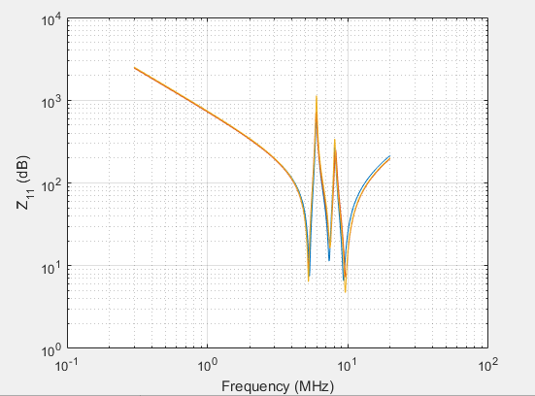
$$L_{SV}$$
$$C_{TV}$$

Figure Ⅲ.7 Z11 of resonant magnetic field coupling

comment
As a result of the mutual coupling between the receiving coil and the repeating coil (extracting by MATLEB 2016). Both ends of the peaks were strongly influenced by the mutual coupling between the transmitting coil and the repeating coil. The slope in the low-frequency region up through the first resonance peak is associated with the tuning capacitance of the transmitting coil. Above the final resonance peak, the slope is determined by the total inductance. The observed results confirm that when the number of vertically coupled coils was increased to three, the number of series resonances increased to three and the number of parallel resonances increased to two.
There are 2 peaks because in Multi-coil configuration vertical 3 electrical circuits the first is the transmission coil the second is repeating coil “It allows the transmission of currents by means of magnetic induction” the third is receiving coil so we have peak between a transmission coil and a repeating coil and another one between the repeating and the receiving coil.

Note
The result obtained by IEEE TRANSACTIONS ON MICROWAVE THEORY AND TECHNIQUES is:
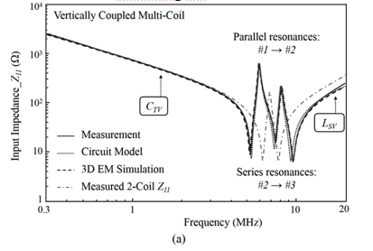

Measurement results related to the changes in the resonances of the input impedances of multi-coil resonant WPT systems. (a) Vertically coupled multi-coil system. When the number of vertically coupled coils was increased to three, the number of series resonances increased to three and the number of parallel resonances increased to two.

III.5 Multi-coil configuration horizontal

III.5.1 Simulation results
An additional receiving coil is placed horizontally to the side of the existing receiving coil. For the coefficients of the frequency terms leads to the Laplace transform. Between the transmitting and receiving coils. This type of WPT system applies a repeating coil, which can achieve higher power efficiencies and longer charging distances, despite the difficulty in designing a system of this type. In the case of a horizontally coupled multi-coil system, as shown in Fig. below the transmitting coil is sufficiently large to charge two or more devices simultaneously, and an additional receiving coil is placed horizontally to the side of the existing receiving coil [1].

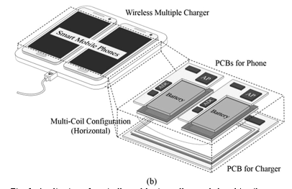
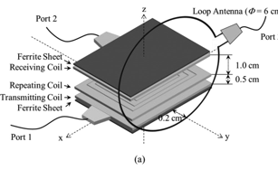
Figure Ⅲ.8 Multi-coil configuration Horizontal inside smartphone

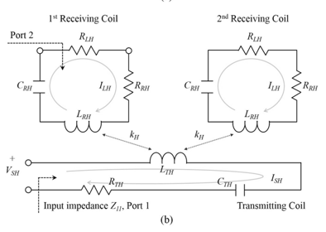

Figure Ⅲ.9 related electrical circuits of Multi-coil configuration vertical
$$\left[\begin{matrix}V_{SH} \\ 0 \\ 0\end{matrix}\right]\left[\begin{matrix}R_{TH}+j\left({ωL}_{TH}-\frac{1}{{ωC}_{TH}}\right) & -j{ωM}_{H} & -j{ωM}_{H} \\ -j{ωM}_{H} & \left(R_{RH}+R_{LH}\right)+j\left(ωL_{RH}-\frac{1}{ωC_{RH}}\right) & 0 \\ -j{ωM}_{H} & 0 & \left(R_{RH}+R_{LH}\right)+j\left(ωL_{RH}-\frac{1}{ωC_{RH}}\right)\end{matrix}\right]$$  $$\left[\begin{matrix}I_{SH} \\ I_{LH} \\ I_{LH}\end{matrix}\right]$$ | III.15

Using (3) and considering the cross coupling the current in each resonator can be expressed by:

$$\left\{\begin{aligned}I_{SH}=\frac{V_{SV}}{R_{TH}+j\left({ωL}_{TH}-\frac{1}{{ωC}_{TH}}\right)+\frac{2ω^{2}{M_{H}}^{2}}{\begin{aligned}R_{RH}+R_{LH}+j\end{aligned}\left(ωL_{RH}-\frac{1}{ωC_{RH}}\right)}} \\ I_{LH}=\frac{j{ωM}_{H}}{R_{RH}+R_{LH}+j\left(ωL_{RH}-\frac{1}{ωC_{RH}}\right)}\end{aligned}\right.$$ | III.16
Where $Z_{in}=\frac{V_{SH}}{I_{SH}} =Z_{11}$
$${Z_{11}=R}_{TH}+j\left({ωL}_{TH}-\frac{1}{{ωC}_{TH}}\right)+\frac{2ω^{2}{M_{H}}^{2}}{\begin{aligned}R_{RH}+R_{LH}+j\end{aligned}\left(ωL_{RH}-\frac{1}{ωC_{RH}}\right)}$$  $$=\frac{\left[R_{TH}+j\left({ωL}_{TH}-\frac{1}{{ωC}_{TH}}\right)\right]\left[\begin{aligned}[R_{RH}+R_{LH}+j\end{aligned}\left(ωL_{RH}-\frac{1}{ωC_{RH}}\right)\right]+2ω^{2}{M_{H}}^{2}}{\begin{aligned}R_{RH}+R_{LH}+j\end{aligned}\left(ωL_{RH}-\frac{1}{ωC_{RH}}\right)}$$ | III.17
Where $L_{TH}C_{TH}$=$L_{RH}C_{Rh}=LC$, and $M_{H}=K_{H}\sqrt{L_{TH}L_{RH}}$
Hence
$$Z11=\frac{\left[{ωC}_{TH}R_{TH}+J\left(ω^{2}LC-1\right)\right]\left[ωC_{RH}\left(R_{RH}+R_{LH}\right)+j\left(ω^{2}LC-1\right)\right]+2ω^{4}K_{H}L_{TH}L_{RH}{C_{TH}C}_{RH}}{\begin{aligned}j\begin{aligned}{ωC}_{TH}\left[ωC_{RH}\left(R_{RH}+R_{LH}\right)+j\left(ω^{2}LC-1\right)\right] \\ \frac{\left[-j{ωC}_{TH}R_{TH}+J\left(ω^{2}LC-1\right)\right]j\left[-jωC_{RH}\left(R_{RH}+R_{LH}\right)+\left(ω^{2}LC-1\right)\right]+2ω^{4}L^{2}C^{2}}{j{ωC}_{TH}\left[-jωC_{RH}\left(R_{RH}+R_{LH}\right)+\left(ω^{2}LC-1\right)\right]}\end{aligned}\end{aligned}}$$ | III.18
And
$$Z11 horizental =\frac{\left(j{ωC}_{TH}R_{TH}+1-ω^{2}LC\right)\left(jωC_{RH}\left(R_{RH}+R_{LH}\right)+1-ω^{2}LC\right)-2ω^{4}L^{2}C^{2}}{j{ωC}_{TH}\left[jωC_{RH}\left(R_{RH}+R_{LH}\right)+\left(1-ω^{2}LC\right)\right]}$$
$$ZZ11 horizental =\frac{\left(j{ωC}_{TH}R_{TH}+1-ω^{2}LC\right)\left(jωC_{RH}\left(R_{RH}+R_{LH}\right)+1-ω^{2}LC\right)-2ω^{4}L^{2}C^{2}}{j{ωC}_{TH}\left[jωC_{RH}\left(R_{RH}+R_{LH}\right)+\left(1-ω^{2}LC\right)\right]}$$ | III.19

II.5.2 Simulation results
We have applied this equation to the demand, and the result is as follows “the program on MATLEB”

- The program is

clear;
clc;
format long g;
RTh=3.4;
CTh=131.81e-12;
LTh=4.181e-6;
LRh=2.61e-6;
CRh=211.1e-12;
RRh=2.1;
RLh=1;
kh=0.13;

CThRTh=CTh*RTh;
LC=LTh*CTh;
CR4L=CRh*(RRh+RLh);
freq=1e6*linspace(0.3,20,1000);
omega=2*pi*freq;
omega2=omega.^2;
omega4=omega2.^2;
omega2LC=omega2*LC;
omega4KLC=2*omega4*kh.^2*LC.^2
jomega=j*omega;
P1=jomega*CThRTh+1-omega2LC;
P2=jomega*CR4L+1-omega2LC;
NUM=(P1.*P2)-(2*omega4*kh.^2*LC.^2);
DEN=(jomega*CTh).*P2;
Z_11hori=NUM./DEN;
loglog(1.e-6*freq,abs(Z_11hori));grid;figure(gcf);

The result is :

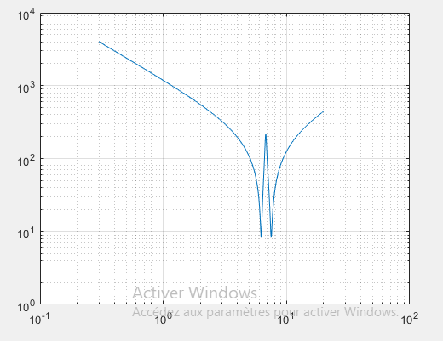
$$L_{SH}$$

$$C_{TH}$$

Figure Ⅲ.10 Z11 of resonant magnetic field coupling
- Comment

As a result of the mutual coupling between the receiving coil and the repeating coil. Both ends of the peaks were strongly influenced by the mutual coupling between the transmitting coil and the repeating coil.
The slope in the low-frequency region up through the first resonance peak is associated with the tuning capacitance of the transmitting coil. Above the final resonance peak, the slope is determined by the total inductance. The observed results confirm that when the number of vertically coupled coils was increased to three, the number of series resonances increased to three and the number of parallel resonances increased to two.

- Note
The result obtained by IEEE TRANSACTIONS ON MICROWAVE THEORY AND TECHNIQUES is:
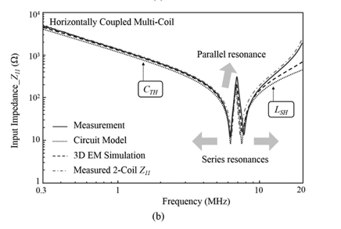
Horizontally coupled multi-coil system. When the number of horizontally coupled coils was increased, the numbers of series and parallel resonance peaks did not change.

III.6 Conclusion
Magnetic resonance has been the cornerstone of non-radiative wireless power transmission (WPT) and has become among the most effective solutions for wireless power transmission.
At the design stage of the WPT system, we can predict changes in the resonance peaks and check their frequency compliance (We have used the method 2 for simple, horizontal and vertical).
We can reduce the emission and radiated interference from EM by changing the configuration of the twin coils, changing the frequency of their power source, or using shielding. The results presented in this paper may provide solutions to reduce radiated EM emissions and interference when designing multi-coil setups and WPT systems that use such multi-coil resonant systems.
Through what we have studied, we have identified three types simple horizontally and vertically, and each one has a purpose and a reason for use.
It will be the best way for transmission of power.

Chapitre IV

General conclusion

General Conclusion

At the end, we have realized the purpose of this work to study the electromagnetic emission radiated from wireless energy transmission in different fields but we have focused on smartphone charging.
With explanations and definitions of this technology and we talked about the different areas.
For better study, it we have realized configuration of coupled coils; we can predict the changes in resonance peaks simulation.
The results presented in this paper may provide solutions for the reduction of EM radiated emission and interference when designing multi-coil configurations and WPT systems that utilize such resonant multi-coil systems by the MATLEB tool «MATLEB 2016" for the 3 types of simple ,horizontal and vertical.

References

References

[1] : IEEE TRANSACTIONS ON MICROWAVE THEORY AND TECHNIQUES
[2] : Sarah . S ,Yamina . Z , Mémoire de master en électromécanique université de Mohamed Seddik ben Yahia Jijel faculté ST, 2021
[3]: International Journal of Scientific & Engineering Research, Volume 6, Issue 10, October-2014 ISSN 2229-5518 Wireless Power Transmission

[4] Recent Advances in Circuits Wireless Power Transfer through Inductive Coupling
Mohamed A. Hassan, A.Elzawawi

[5] Electronics 2018, 11, 296 WPT Applications: An Optimized Case Study
[6]:https://electrotopic.com , 2023 ,6 , 21
[7]: Fundamentals of Electric Circuits (7th edition) (z-lib.org)

